Hostinger Review 2022 – Is this the right Hosting for you
Slug: Hostinger Review 2022 – Is this the right Hosting for you
Meta Description: Hostinger is the fastest-growing private hosting provider in the world. They provide Shared, Reseller, and VPS hosting services. Everything is focused on providing quality hosting services to website owners.
Hostinger Review 2022 – Is this the right Hosting for you
Perhaps you have been looking for a hosting provider to host your website and email campaigns. You've come across Hostinger offering you all your needs for a website for just 2.99$/Mo and wondered if this is the right choice for you?
Well, We are here to give you an honest review on why it's a good choice for some and not so good for others. Let us tell you that when it comes to hosting, it's mostly about price and features.

It would help if you had reliable support and service to keep your website up during an outage. That's why we looked at Hostinger — one of the best hosting providers on the market. This Hostinger review tells you everything you need to know about their service and how they may be able to help you in your online business.
Let's dive in
Everything a Beginner Needs to know about Hostinger
Hostinger is a leading provider of web hosting, domain name registration, and SSL certificates. We offer managed Linux web hosting, Managed Windows hosting, Domain Name Registration, and SSL Certificates.

Hostinger provides multiple web hosting options for businesses looking for an affordable solution that allows them to host various websites simultaneously on one hosting account.
Hostinger is known for its reliable servers and high-quality security features
Its servers have been tested by qualified technicians and passed all tests with flying colors. Hostinger also offers custom environments so that you can choose the plan that best matches your needs and requirements.

The company has built its reputation on its fast response time and excellent customer service.
It also offers domain name registration, email marketing tools, and other tools that are essential for small businesses or individuals who want to start their online ventures.
With that, let's move ahead in our Hostinger Review
Hostinger: The Good and the Bad
Hostinger is undoubtedly one of the best hosting providers out there, but as we all know, everything has its pros and cons, so let's move ahead and look at the pros and cons of Hostinger, after which you can decide whether it's worth it for you or not.
The Good
Fast Loading Time
According to Yoast, website speed is one of those factors that's very crucial in the ranking of your website. No matter how good your content and branding are, your message will never be able to reach the targeted audience because slow-speed websites don't rank.

We tested Shared Hosting, VPS hosting as well as WordPress hosting, and the results were excellent. On average, every site took around 475 milliseconds to load, thanks to their servers located all around the world.
With Hostinger, your problem with the speed of a website is just a thing of the past, and now you can focus more on business.
Unbelievable Pricing:
The next thing in our Hostinger review that we want you to highlight is that Hostinger offers amazingly cheap pricing. Hostinger offers three different kinds of Hosting.
- Single Shared Hosting
- Premium Shared Hosting
- Business Shared Hosting
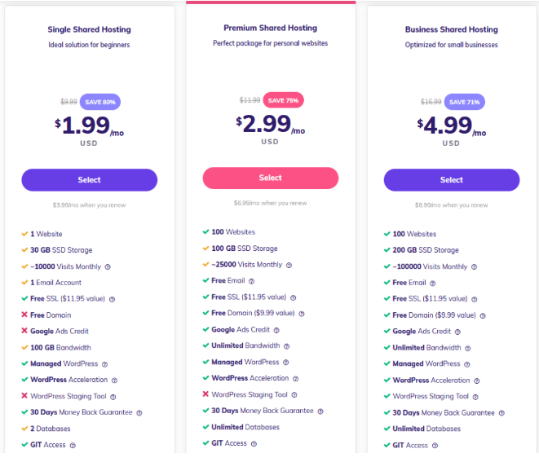
Remember that this is the price only if you want to buy Hostinger for four years. Otherwise, there is a different price range.

Single Shared Hosting: Single Shared Hosting is suitable for websites that have less than 10,000 monthly visits and do not require a high level of performance.
The most basic plan in this category is $1.99 per month, and it allows you to create up to 1 site with a maximum of 30 GB SSD storage space.
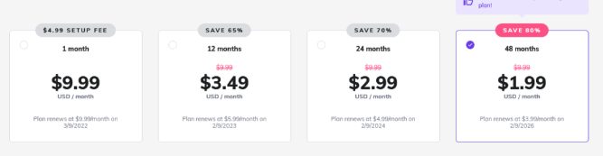

Premium Shared Hosting: Premium Shared Hosting has a higher price than the previous option, but it provides more features and higher levels of performance.
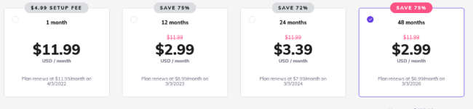
This plan starts at $2.99 per month if you opt for a four-year plan, and it allows you to create up to 100 sites with a maximum of 100 GB of SSD storage space.

Business Shared Hosting: Business Shared Hosting offers even more features than the previous options, but its price is higher as well. It starts at $4.99 per month for a four-year plan and allows you to create up to 100 sites with a maximum of 200 GB of storage space.
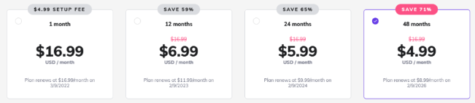
Money-Back Guarantee :
Not happy with the Hostinger? That's not a big deal. In 30 days, you can ask for a refund, and they will gently refund you, and you are happy to move on to some other Hosting providers.
Free Domain

Hosting with a free domain is a great way to start, especially if you're just starting as an online business. When you have your hosting web account with Hostinger, you can use it for any purpose you want.
Many other Hosting providers charge you extra if you want a domain name or sometimes don't even offer a Domain, but Hostinger provides both Hosting as well as a domain name for your website without any additional fees
Free Website Builder
Not sure how to build a website? Hostinger's Partnership with Zyro will give you access to their plan for free. Zyro provides you with all of the tools you need to create a website, including templates, themes, and layouts to help you create a website using our powerful Drag & Drop builder.
The Bad
Missing Phone support
Hostinger only supports live chat if you need help, but the website states that they can contact you via phone.
If there's an issue with your account and the support team does not resolve it, you can reach out to them over the phone, but that's not a deal-breaker. Their live support is up 24/7 to help you with any inconvenience.

Missing Features on the different plans
The more money you pay, the more you get. This is very much true in the case of Hostinger. We have noticed that if you opt for their entry-level plans, you won't get Content Delivery Network (CDN) as well as daily automatic backup.
We suggest you look at the features you want to have inside your website carefully before choosing any of their plans to avoid any inconvenience in the future.
Final Verdict
With that, we are sure that now you will be able to decide whether to choose Hostinger to run your website or not, but if you are still in doubt, we will suggest you give it a shot.
And the choice is clear. No matter whether you are a designer, a student of Information Technology, or a writer/blogger/ producer of any content, Hostinger's experienced and knowledgeable team of developers can help you make your website a reality. Better yet, its easy-to-use platform makes it highly affordable to do so. You can always opt for a refund if you don't like their service, which we bet has a rare chance.
We hope that this review has helped you in clearing all of your doubts related to the Hostinger. Keep following us for more blogs like these in the future.

