Elementor Review 2022 – Everything you need to know
Meta Description: Elementor is the most feature-rich, fastest, and easiest way to design for WordPress. It will revolutionize your approach to web design, making it easier than ever before, even if you have zero knowledge of code or web design

Introduction
Everybody knows that building a website can be a tedious and complex thing. You have to worry about layout, styling, structure, and more. This is why page builders are gaining traction every day. They give you a simple-to-use interface that allows you to quickly build beautiful websites without knowing all the programming language behind them. Now, there are a lot of page builder plugins out there. Some cost money, and some are free, but today we’re going to focus on Elementor.
Elementor is a powerful WordPress Page Builder plugin that can help you create beautiful websites and landing pages. We’ll examine everything it offers and explain the pros and cons of using Elementor for your next project.

Elementor Overview

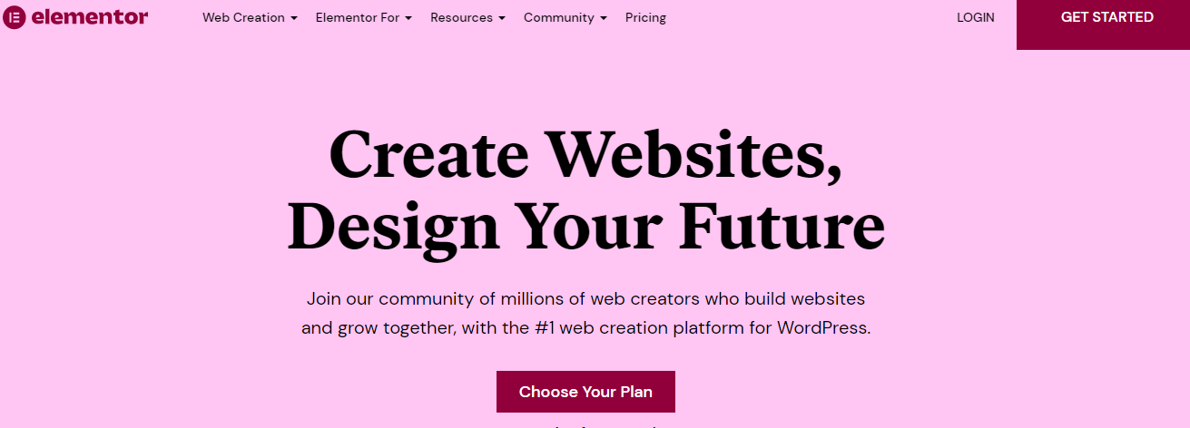
Elementor is a powerful page builder that allows you to build any page you want without writing a single line of code. It can be used by anyone who wants to create beautiful and unique layouts without worrying about writing lines of code. The drag-and-drop interface makes it easy for anyone with no coding experience or knowledge, which is why Elementor has become so popular with beginners and experts in web development.
The range of features offered by Elementor is quite broad and includes everything from simple image sliders to
With Elementor, you can create any page, such as:
- Homepage (landing page)
- About us page
- Blog post pages
- Contact us page

Pros of Elementor Page Builder
- Elementor Blocks
Elementor has a very intuitive drag & drop interface, making it easy to design your website without writing any code. But if you need more control over your layout, Elementor also allows you to add custom blocks to your pages and posts. These advanced elements can be used for anything from adding testimonials or contact forms to creating custom menus or sidebars. This gives you more flexibility when designing your site and lets you create any layout you want with just a few clicks.
- Popup Customization
Elementor’s Popup feature allows you to create beautiful popups that convert visitors into subscribers and customers. With Elementor’s Popup builder, you can easily choose from different templates and customize them to fit your needs. You can also use the built-in drag-and-drop editor to create your unique popup design without any required coding skills.
- Optimized for Mobile
Google has a mobile-first indexing policy. If your site doesn’t look good on phones, it will be penalized by Google. Elementor is optimized for mobile, so you can display your website easily on phones, which will help your SEO rankings.

- WYSIWYG editor
One of the most impressive features of Elementor is its WYSIWYG (What You See Is What You Get) editor, which allows you to see what your page will look like before publishing it. This gives you more control over your site design than other page builders, which can be frustrating when you want to make small changes but need to go back and edit every single element before publishing again.
With Elementor, you can make all your changes directly on the live preview, which saves time and increases efficiency.
- SEO and Ecommerce Friendly pages
SEO is the main priority for most business owners. Customers will find your products if they search for them on Google, so you must ensure your website is optimized for search engines.
Elementor has a built-in SEO option that allows users to optimize their pages for search engines like Google, Yahoo, and Bing. This means that customers can easily find what they are looking for on your website by searching for keywords related to your products or services.
- Responsive Design
According to Moz, responsive design is one of the key factors in ranking your websites.
Responsive design allows your website to look good on all devices, from desktop computers to mobile phones and tablets.
This means visitors don’t have to pinch or zoom fin or your content to be readable on their screens — it all scales automatically!
- It saves a lot of money and Time
In this Elementor review, we deeply explored the platform's features, benefits, and usability. We hope our findings will help you decide if it’s right for your project.
Elementor is a great page builder offering advanced functionality and an easy-to-use interface. It's perfect for users who don't want to learn how to code or hire freelancers because they can design their websites entirely from scratch on their own time—and it's all done in a few hours!

There are many different templates available with built-in elements such as sliders and menus that allow you to create beautiful designs without having any coding experience (although we highly recommend taking some basic web development classes).

Cons of Elementor Page Builder
- Elementor has a steep learning curve.

If you’re new to WordPress, Elementor can take time to learn how it works and how to use it. The good news is that tons of free tutorials on YouTube and other sites will help you understand the ins and outs of this page builder plugin. Just be prepared for some trial and error as you get started!

- You can easily break your site if you don’t know what you’re doing.
While Elementor isn't necessarily hard to use once you've learned its essential functions, it's important to remember that plugins like this allow users with little or no coding experience access to powerful tools that can easily break websites if used incorrectly or carelessly.

As always, make sure that before using any new plugin on your site (especially one like this), do enough research ahead of time so that when something goes wrong with your site later down in the future after installing elements such as these on it (which they inevitably will), fixing those problems won't cost too much money.

Pricing Plans and Features of Elementor
Elementor pricing plans are affordable and easy to understand. As a WP theme builder, Elementor allows you to create your custom website easily. Their pricing plans are not expensive or cheap, but rather very affordable for all types of businesses in any niche.
Elementor pricing plans include:
- Essential plan –$49/month
- Expert Plan –$199/month
- Studio Plan – $499/month
- Agency Plan-$999/month



Conclusion
Undoubtedly, It’s one of the most effective and flexible tools, with plenty of customization options and many pre-made templates. Using Elementor for your business can save you time and money on custom design projects.
Elementor has been around for over five years, so it’s proven reliable regarding stability and security (two critical factors when choosing a WP theme).

Elementor’s latest version adds even more features to its already impressive list, making it an even better option for those who want control over their site’s design. If you want to create modern web pages without additional plugins or themes (and don’t mind paying monthly), then Elementor may be right up your alley!

If you like this blog, then make sure to check out Andlang; Andlang is a digital agency specializing in storytelling, visual design, and technology. Our mission to be the best web company in the world springs from our roots as a team of entrepreneurs who believe in the power of great ideas. We help businesses connect with their audiences, drive sales, reduce costs—and solve any business problem you can imagine

