Universal Stablecoin Backed by Bitcoin
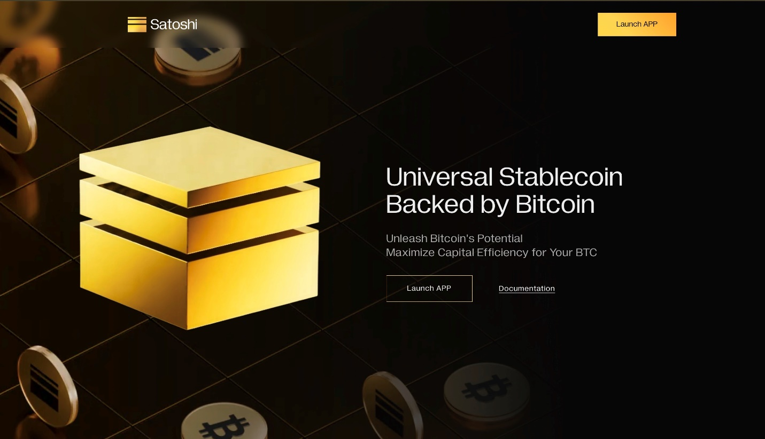
Universal Stablecoin Backed by Bitcoin

Unleash Bitcoin's Potential
Maximize Capital Efficiency for Your BTC

Your secure gateway to DeFi with Bitcoin
We ensure stability, profitability, and security of your investments with these key features
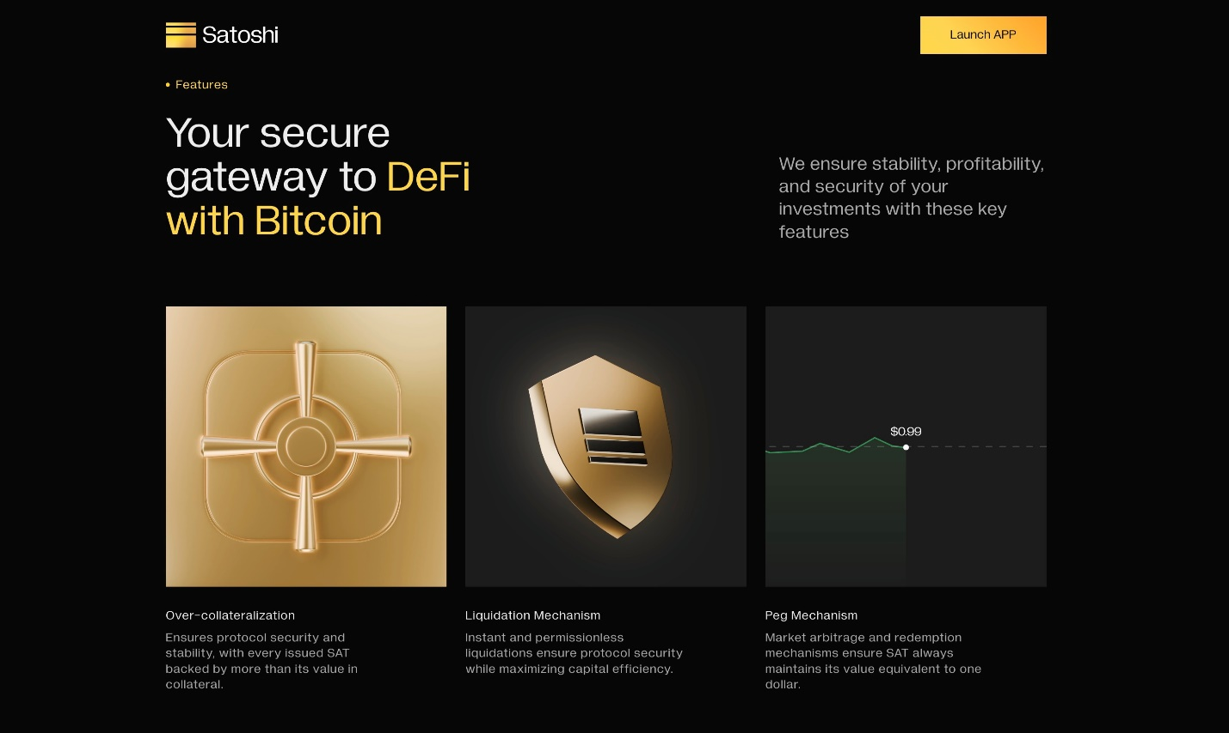

Over-collateralization
Ensures protocol security and stability, with every issued SAT backed by more than its value in collateral.

Liquidation Mechanism
Instant and permissionless liquidations ensure protocol security while maximizing capital efficiency.

Peg Mechanism
Market arbitrage and redemption mechanisms ensure SAT always maintains its value equivalent to one dollar.

Universal Stablecoin
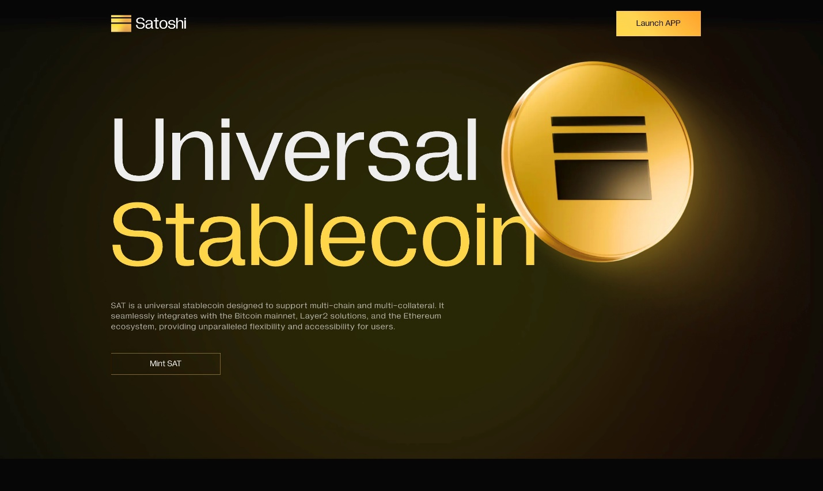
SAT is a universal stablecoin designed to support multi-chain and multi-collateral. It seamlessly integrates with the Bitcoin mainnet, Layer2 solutions, and the Ethereum ecosystem, providing unparalleled flexibility and accessibility for users.

How to Mint SAT
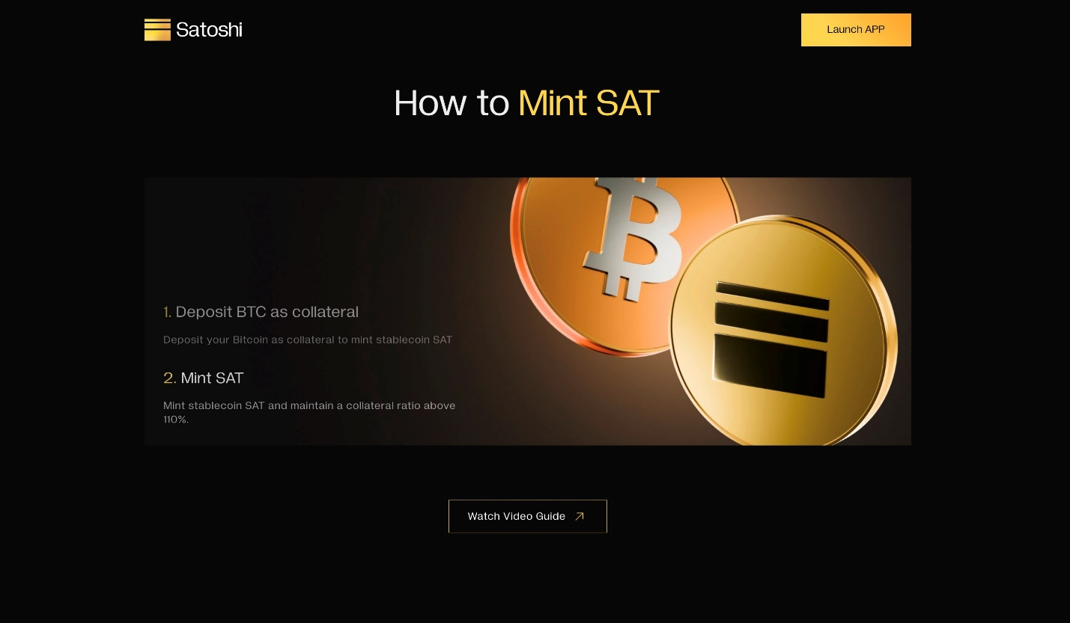
Deposit BTC as collateral
Deposit your Bitcoin as collateral to mint stablecoin SAT
Mint SAT
Mint stablecoin SAT and maintain a collateral ratio above 110%.

With SAT, You can ...
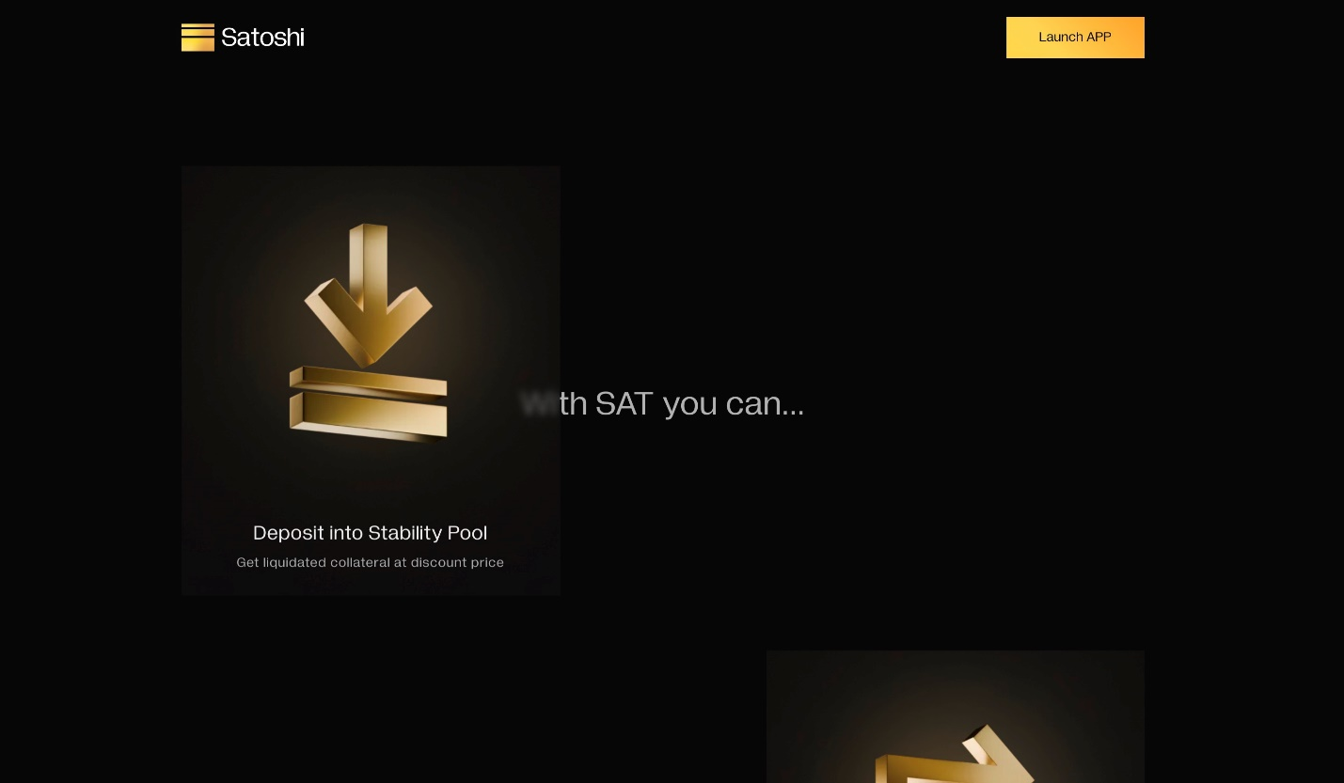
Deposit into Stability Pool
Get liquidated collateral at discount price
Swap SAT on DEX
Trade for any assets with your SAT
Leverage Your Yield
Swap SAT for LST to amplify your return
Earn interest by lending SAT
Supply SAT on lending protocol to earn interest

FAQ
- What is Satoshi Protocol ?
Satoshi Protocol is a revolutionary "universal" stablecoin protocol backed by Bitcoin. It allows users to deposit BTC/staked-BTC/USDC as collateral to mint the stablecoin $SAT on both Bitcoin mainnet and multiple L2s.
- What is SAT stablecoin and how to use it ?
The SAT stablecoin is over-collateralized, featuring instant liquidation and redemption modules, forming the cornerstone of BTCFi.

- What is Stability Pool ?
Users can deposit SAT into stability pools to earn liquidated collateral at discount.
If a user's collateral value dips below the MCR due to BTC price fluctuations, a liquidation is triggered. The user's BTC collateral is sold at a discount to Stability Pool providers in order to repay the SAT loan. This mechanism protects the protocol and prevents borrowers from taking on excessive debt.

- How to create position on Satoshi Protocol ?
https://www.youtube.com/@SatoshiProtocol/videos

- How Satoshi Protocol ensures stability of US dollar price and SAT?
  - The SAT stablecoin is over-collateralized, featuring instant liquidation and redemption modules, forming the cornerstone of BTCFi.
  - Over-collateralized, Instant liquidation and Peg mechanism.

▸ Resources
Website : satoshiprotocol.org
Twitter : https://x.com/Satoshi_BTCFi
Blog : https://blog.satoshiprotocol.org/
Doc : https://docs.satoshiprotocol.org/intro/introduction
Telegram : https://t.me/satoshi_sat
Discord : https://discord.gg/satoshiprotocol

