Transform Your Space: Mastering the Art of Custom Built-Ins and Cabinets, Bookcases, Mudrooms, and Mantles.

Meta Description
Learn how custom built-ins, cabinets, bookcases, mudrooms and mantles can transform a house. Know how they add appeal to your home and life by styling, functionality, and organization.

1. Introduction
The world of built-in cabinets & bookcases, mantles and intricate mudrooms is confusing. The special clusters cannot be mined from this field because these encompass an ideal combination of aesthetics, symmetry and effectiveness. Shelves, special cabinets and bookcases apart from the perfect charm of mantles create a warm feeling through aesthetics. The only non-practical aspect of these personalized mudrooms is that they correspond with an organizational necessity in every home. To this end, let us take a look at these useful and creative additions that can turn your house into an inviting sanctuary.

2. The Concept of Custom Built-ins Cabinets & Book Cases
Built-in cabinets and bookcases are installed on the walls of houses. They are specially made for the sole purpose of matching a specific space and serving some needs. As for the built-ins, they are not standing separate from the floor but fusing with it completely while custom furniture is meant to be personalized as well as functional. Depending on dimensions, materials, colours and finishes appropriate for the interiors of a house they can be altered. It also results in visual balance and as a result, increases the value of your home.
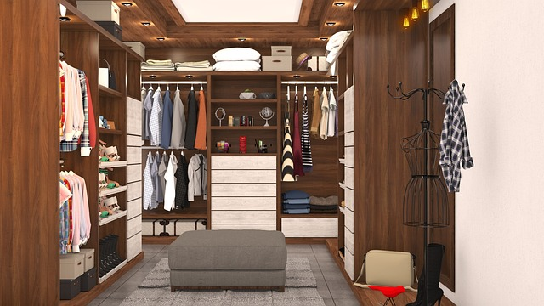
Built-ins cabinets and bookshelves strongly influence the overall look of a home. Their smooth integration into the architecture enables to create a space, which appears less fragmental and more cohesive. They can also become nice centrepieces if you know how to plan and design them in such a way that they have some sort of character element like what is present on your rooms. Along with the advantages that they give, such custom features can be a stunning built-in bookcase paneling your fireplace or even a modern radiator cabinet in the hallway which provides an unparalleled opportunity for display of special pieces – collections books.

3. Must-Have Mudroom Built-ins
Mudroom built-ins are special architectural elements that, as a rule, become an integral part of your home’s structure. They are custom storage features that may include coat racks, utensils protrusions used for putting footwear in place a bench on which one could sit and even cabinets or drawers storing seasonal items of sports equipment. They may also include shelves along with the space for mail, keys and other minor items.
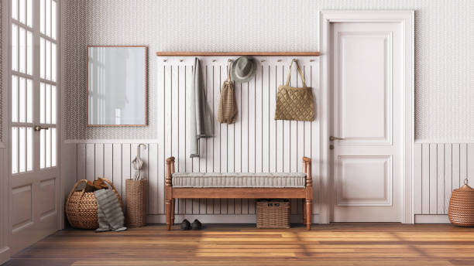
What makes the mudroom built-ins truly stand out is their functionality. Being a perfect buffer zone between the exterior world and your home, mudrooms have an increased tendency to attract clutter. By introducing built-ins, it is certainly easier to keep things in order because every item has its own space. For instance, having cabinetry with drawers or locker-style cabinets would help organize sports equipment, backpacks and even pet supplies.
Mudroom built-ins work not only effectively but also attractively, and they have a lot of practical real-life examples. The variety of designs is quite diverse, ranging from simple Scandinavian-style to rustic farmhouse styles that meet the needs of all aesthetic preferences and storage capabilities.
4. All About Mantles
Interpreting a mantel requires the realization of the architectural and decorative elements that combine to influence one’s fireplace. A mantel is simply an overhang above the fireplace where one can place decorations such as family photos, pictures or artworks and even seasonal décor.
In the living room, mantels significantly contribute to its architectural wholeness by creating a central point that attracts attention and glues everything together. A beautifully constructed mantel creates a sense of warmth and hominess that defines the personality of the living room.
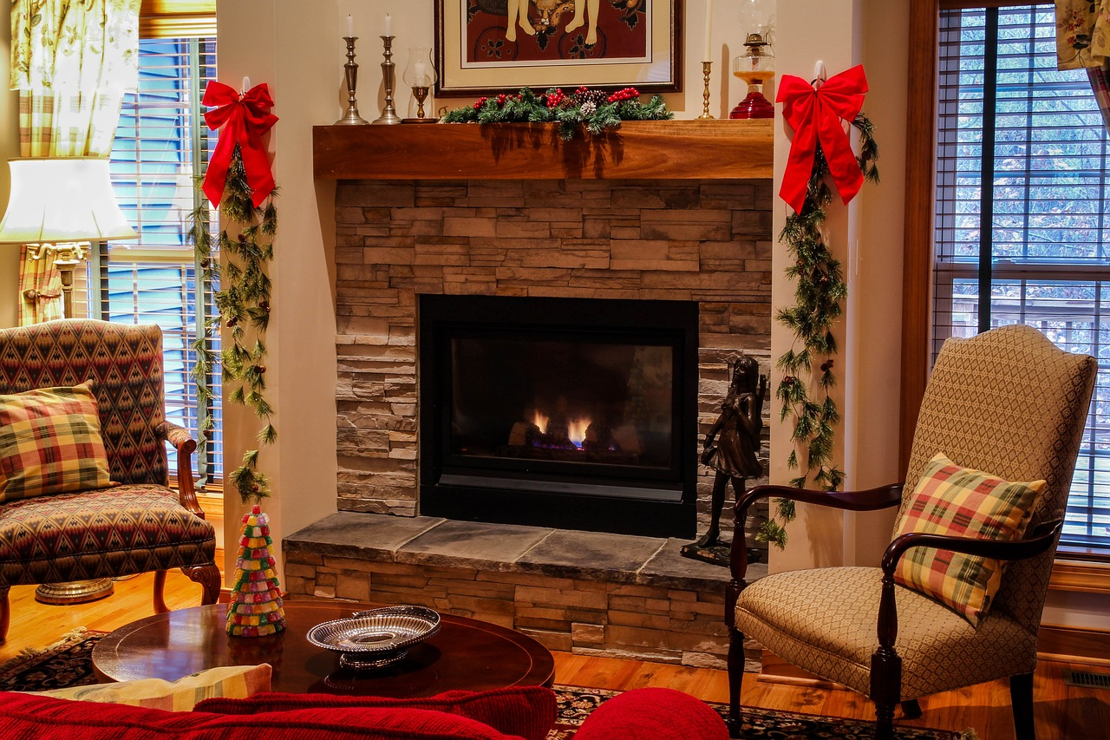
It is also important to choose the most appropriate type of material and design for mantelpieces to preserve harmony in this room. The material should complement the rest of its surroundings – be that a classy quality wood, or elegant marble. The inspiration, from gaudy and traditional to minimalist and modern should reflect your personality as well as compliment the atmosphere of that particular room.
5. The Process of Having Custom Built-ins, Cabinets & Bookcases
- Initial Consultation: This is the first and main stage where the client discusses specific requirements for the customer with the designer. Size measurements of the existing area are made and style, colour, and material preference is determined.
- Design Concept: According to the demands of a given client and an agreed consultation, the designer makes up with an initial design. This encompasses drawings and/or 3-D models, aiding the customer in seeing as much detail of what to expect at completion.
- Design Finalisation: The concept is then reviewed by the designer and client. These modifications are done and finishing touches added till the client is satisfied.
- Execution: The craftsmen then set to work with the final design. This includes proper building, fitting and polishing to get the desired product.
In order to keep these bespoke pieces looking their best, dust regularly, remove marks quickly whenever they occur; never apply harsh chemicals of any kind and occasionally give them an expert polish and refinishing.
6. The Impact of Built-ins, Cabinets & Bookcases on Interior Design
Potent elements in interior design include built-ins, cabinets bookcases mudrooms and mantles. They complement and improve the aesthetics of a house’s functionality by contributing to personalization. They can even subtly influence the movement of spaces or identify crucial architectural changes in one-storey residences. It requires proper planning and the right choice of materials. You need to take into account the dimensions of available space, aesthetic appeal, functional specifications and which message is going to be sent by this artefact in the room.
7. Conclusion
Thus, investigating and grasping the essence of built-in custom cabinetry cabinets & bookcases practical mudrooms elegant mantles has revealed their transformative capacity in your surroundings. It’s more than just an aesthetic choice; it is about usefulness, customization tendency or what they say tailoring the space to suit your style and optimization because of these singular traits. With these specially designed features, you can truly transform your house into a “home” that expresses your character and taste.
Don't hold back! With more than 38 years of experience, we are ready to provide you with sophisticated bespoke built-ins that add personality and diversity while leaving no inconsistencies. In Paul Morse Carpentry meeting your aesthetic dreams and professional results is guaranteed. Walk the path of home transformation with us today.

