INDX Whitepaper
July 2024

Abstract
Cryptoindex is a decentralized index-building protocol that democratizes access to the cryptocurrency market. With access to 30K+ coins on DEX, as well as extensive index customization options, index creators can monetize their community. Moreover, users, regardless of their level of immersion in the world of finance, will be able to choose from 1K+ indexes the instrument from trusted experts that match their risk parameters and their expectations.

Content
Abstract 1
Content 2
1. Introduction 3
Indexes: Strong in Traditional Finance, Blue Ocean in Crypto 3
Intended audience 4
2. Platform Features 5
Benefits 5
Functionality 6
Index Creation and Management Process 6
Fees Structure 8
Changing the Composition of Indexes 9
Voting process 10
3. INDX Tokenomics 12
Allocations, Lockup, and Vesting 12
Core Utility of INDX 14
Additional Utility of INDX 15
More details about INDX utility 16
Creators Subscription 16
Index Holders Fees 17
Incentivization Program 19
Additional Rewards for Index Holders 21
Additional Rewards for LPs 24
Advertising Promotion 26
Referral Program 27
Burning 28
4. Security 30
5. Risks 31
6. Project Roadmap 32
7. Legal Disclaimer 33

1. Introduction

Indexes: Strong in Traditional Finance, Blue Ocean in Crypto
An index is a type of financial instrument that tracks and measures the performance of a specific basket of assets (stocks, bonds, cryptocurrencies, etc.). It enables index holders to measure and contribute to the overall performance of the financial market as a whole, rather than the instruments.
Indexes are a versatile tool that allows users to achieve various goals. The key advantages include:
- Unified Instrument: An instrument that enables holders to receive passive income by tracking the overall market performance.
- Time Savings on Analysis: Utilizing indexes reduces the time required for portfolio construction, eliminating the necessity to study a wide range of market sectors and numerous companies within each industry.
- Elimination of Rebalancing Requirements: Using public indexes eliminates the routine process of rebalancing, which involves multiple buy/sell operations.
- Diversification: Indexes are a multi-asset composite that helps reduce the impact of individual components, thereby lowering overall portfolio volatility.
- Long-Term Performance Advantage: Holding an index long-term offers higher returns compared to active strategies focusing on individual instruments and a high transaction volume.
In traditional financial markets, index trading constitutes a significant portion of the overall turnover of investment instruments. For example, the ecosystem of products directly linked to the S&P 500 generated $224T in index-equivalent trading volume in 2023.
For comparison, during the same period, the trading volume of all cryptocurrencies (spot & perpetual) on TOP10 DEX and CEX amounted to ~$36.3T, and the trading volume of projects in the DeFi category (to which indexes belong) amounted to ~$1T. Thus, the volume of the entire DeFi sector is currently ~0.45% of the S&P 500 products.
Although the DeFi sector remains small in comparison to traditional financial markets, it is growing strongly, with high growth rates. Since 2023, the TVL of projects has grown ~2.6x times to reach the $100B mark. Therefore, index projects will grow dizzyingly due to the growth potential of the DeFi market as a whole.
Despite the popularity of indexes in traditional financial markets, the cryptocurrency space has a limited number of players that provide opportunities to interact with indexes. These platforms do not allow users to fully exploit the benefits for several reasons:
- Limited availability of indexes (not suitable for all strategies).
- Indexes are composed of a small number of tokens (up to 5-7).
- The list of tokens available for index composition is restricted to a few dozen.
- Indexes are rarely rebalanced (once a month, once a quarter, or less).
The Cryptoindex platform democratizes access to one of the most well-known types of holding instruments, incorporating best practices from Web2 and evolving them within the Web3 cryptocurrency space.

Intended audience
By using the Cryptoindex Platform, different categories of users will be able to fully realize their personal needs and get the maximum benefit from interacting with the world of indexes. Cryptoindex Platform will be useful for users, regardless of their size and experience in the financial or cryptocurrency sector, providing its singular advantages:
- Individual users:
  - Beginners: Newcomers to the cryptocurrency sector can use ready-made indexes, each being a portfolio created by an expert, to achieve their goals without knowing the specifics of the market.
  - Experienced Web3 users: Using indexes, the user can significantly reduce the time spent on both the multi-asset portfolio construction phase and the portfolio tracking process, as well as purchase indexes representing a specific industry, for example: DEXs, GameFi, and Meme.
  - Crypto Influencers and Experts:
  - Monetizing Insights: With the knowledge, experience, and trust of the audience, influencers, and industry experts can open a new monetization channel by providing the community with access to proprietary strategies through indexes.
  - Community Building: Creating custom indexes can increase identity recognition, providing an influx of primary audiences or helping expand and retain existing ones.
- Institutional users:
  - Strategic Alignment: Institutional users can create indexes corresponding to their portfolios that are fully consistent with internal risk policies or clients' requests

2. Platform Features

Benefits
The Cryptoindex platform is a one-stop tool in the cryptocurrency space, offering unique opportunities for both beginners and experienced users. The platform allows each user to become an index creator, providing access to the widest list of tokens and flexible settings to create strategies that meet individual needs:
- All Features in One App: A single app with an intuitive interface that opens access to millions of users (from newcomers to experienced ones) to track, create, and share expert opinions with just a few clicks.
- Flexible Builder: Thanks to the Cryptiondex platform, creators can create their index from scratch, completely customizing all components to fit their needs. Creators have control over 30K+ token names in DEX and extensive functionality when forming indexes, allowing them to regulate the commission, components of the index, and their weights.
- Ideas monetization: Index creators have the opportunity to monetize their ideas and industry knowledge, while users have access to a wide variety of instruments to choose from. This enables the implementation of countless strategies tailored to the specific requests of individual users (such as risk minimization, return maximization, hold-to-earn, sectors, industries, etc.).
- Only Relevant Indexes: Each index, before becoming available to the entire audience, goes through a fundraising stage. Indexes that fail to raise the minimum amount of funds within the set timeframes are not admitted to the platform. Therefore, every index is backed by money and reflects the real needs of the audience.
- Direct Holder Participation: The index creator cannot make any decisions or actions without a vote from the index holders. All rebalancing also occurs only through voting.
- Transparency: Unlike TradFi, where users only have access to periodic reports with limited information, the Cryptoindex platform allows tracking all transactions 24/7.

Functionality
At the core of the Cryptoindex platform lies a comprehensive array of features designed to empower users with flexibility and accessibility to crypto finance. These features include:
- Creating Custom Indexes: Experts can create custom indexes by selecting tokens from a list of supported cryptocurrencies and specifying their weights.
- Purchasing Ready-Made Indexes: Access to a variety of ready-made indexes created by experts, catering to different strategies and risk appetites.
- Index Analytics: Live index portfolio data collected by oracles that integrate secure external data feeds into decentralized networks, providing accurate market values for cryptocurrency assets, transparent pricing, and informed decisions for users.
- Analyzing tools: The Cryptoindex platform provides technical tools for analyzing and tracking the movement of coins and indexes. This allows tracking full information about the market movement to enable index buyers to make informed decisions.

Index Creation and Management Process
With its convenient tools, the Cryptoindex platform unites all stakeholders towards common goals, creating a single seamless process of creating, buying, and selling indexes. Cryptoindex allows creators to implement the most daring strategies in indexes, monetizing their knowledge and experience, and allowing users to find the right instrument for their risk profile.
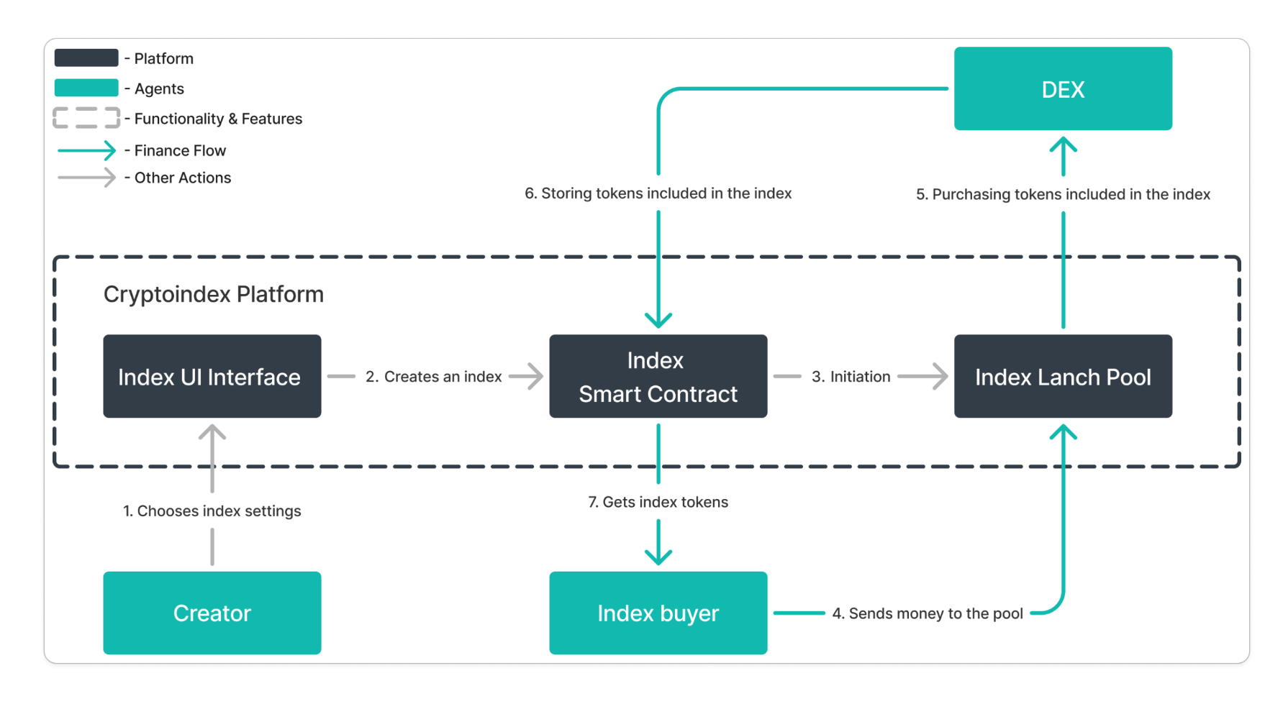
The path starting with index creation and ending with redemption tokenization is detailed below:
- Creation of the Index by the Creator
  - Blockchain Selection: The creator chooses the blockchain on which the index will be created. Access to the specific blockchains is determined by the subscription level. More information in the Creators Subscription section.
  - Token Selection and Weights: The creator selects the set of tokens to be included in the index and determines their weights.
  - Fee Settings: The creator sets the commissions for entry, exit, and management of the index. More information can be found in the Fees Structure section.
  - Initial Funding Level: The index creator specifies the minimum amount needed to launch the index (at least $50K) and the timeframe within which that amount must be raised (3 hours to 30 days).
  - Group purchase: The index purchases are executed in batches and the index creator has to add the size of butches (group transaction), which must be collected to enter and exit the index (at least $10K).
  - Individual entry/exit parameters: The creator of the index has to determine the minimum transaction amount for each participant of the batch with possible options $100, $500 and $1000.
- Launch of a Smart Contract
  - Smart Contract Deployment: A separate smart contract is launched for each index to ensure its security and enforce the parameters specified by the creator.
- Gathering index launch pool
  - Index Selection: Users select the index to which they wish to contribute.
  - Funding the Pool: Index buyers send tokens to the index pool. Once the pool reaches the required liquidity level set by its creator, it is officially launched. If user interest is not sufficient (the required amount has not been raised within the set timeframe), the funds are returned to the users and the index will not be launched (users need to claim tokens to get it back).
- Issue of Tokens
  - Index Token Distribution: After the index launch, index buyers receive index tokens, representing their ownership share of the index pool.
  - Proof of Ownership: These index tokens prove the holder's ownership of the underlying assets in the index.
- Changing the Composition of the Index
  - Proposal for Changes: The creator, a large holder, or a group of users can suggest changes to the composition of the index.
  - User Voting: Users vote on the proposed changes. If approved, the changes are implemented in the index composition. More information may be found in the Changing the Composition of Indexes section.
- Redeeming the Index
  - Token Redemption: Index holders can redeem their index tokens at any time.
  - Return of Assets: Upon redemption, the underlying assets/equivalents in stablecoins (depending on the user’s choice) proportional to the holder's share are returned to the holder.
  - Fee Deduction: Any applicable exit and management fees are deducted during the redemption process.
Some indexes may have liquidity pools on DEXs for index tokens. In this case, users will be able to hold index tokens without the token issuance process on the platform. This way, users can enjoy the same privileges as index token holders on the platform without the need to pay entry/exit fees.

Fees Structure
The existence of commissions on the platform is driven by two key features:
- The creation, purchase, and sale of indexes occurs on the blockchain and is facilitated by a large number of transactions that require the payment of transaction fees.
- There is a need to ensure fair compensation for index creators and liquidity providers.
Thus, the collection of commissions is aimed not only at maintaining the functioning and ensuring the continued development of the platform but also at rewarding its key participants - the community.
Below are all existing commissions, as well as their brief descriptions and possible sizes:
- Entry Fee: Commission charged by the platform from index buyers when buying an index. The fee is set by the index creator and can be 0.5-5.0% of the position size.
- Exit Fee: Commission charged by the platform from index holders when selling an index. The fee is set by the index creator and can be 0.5-5.0% of the position size.
- Management Fee: The platform charges the management fee to index holders monthly at a rate of 0.0-5.0% per annum of the position size or 0.0-20.0% of profit. Commission is paid upon exiting the index, at the same time as the exit fee.
- Transaction Fee: Commission for the operation of buying and selling the underlying assets of the index. The commission is charged for performing transactions on the blockchain. The amount of the fee depends on the actual transaction prices at the time of the transaction.
Users can reduce the size of the commission using the INDX platform token. More detailed information is presented in the Incentivization Program section.

Changing the Composition of Indexes
Over time, the proportions in the indexes may begin to differ from the original ones, necessitating changes to the composition of the index. To address this, a voting procedure has been developed to make such changes. This allows index holders to actively participate in maintaining the integrity of their holdings by locking their index tokens into the voting protocol.
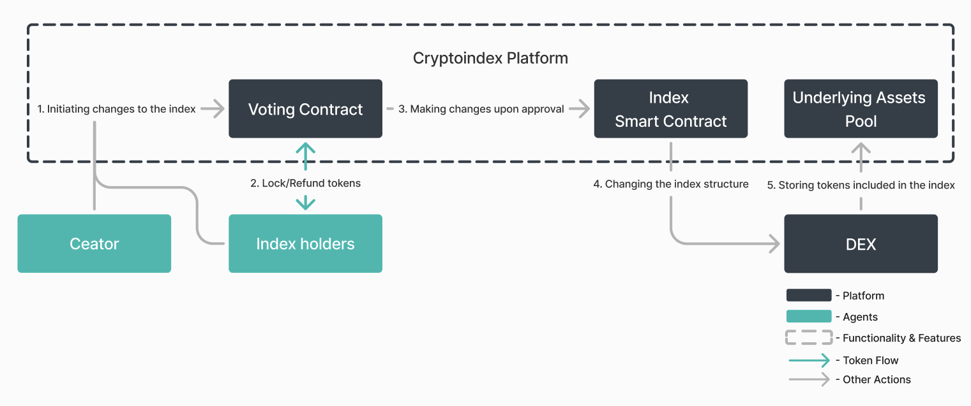
In the framework of the voting, decisions are made regarding the following:
- Adding new coins to the index.
- Changing the weight of existing coins.
- Removing coins from the index.
Payment for the blockchain transaction during rebalancing occurs at the expense of the assets in the index.

Voting process
The proposal to make changes can be made by:
- The creator of the index.
- A holder owns 15%+ of the index tokens.
- A group of holders collectively own 15%+ of the index tokens.
The voting process on the platform includes 4 main stages:
- Soft Commit: (14 days) Before the official proposal submission, all proposals go through a discussion stage on the forum. For the proposal to be submitted for official voting, the following conditions must be met:
  - At least 15% of all token holders participated in the discussion.
  - Out of the voters, 50%+1 voted "for".
- Processing Queue: (1 day) After the question is proposed for voting, it goes into a queue for processing by the platform.
- Announcement: (1 day) Once the platform accepts the proposal, an announcement is made to all index holders.
- Voting Period: (7 days) Voting for the proposal.
Validation and Decision:
- The minimum number of votes for the voting to be considered valid is 30% of the total index tokens.
- If the proposal was made by the creator of the index, it must receive 50%+1 of the total votes in favor to be accepted.
- If the proposal was made by a large holder, it must receive 66%+1 of the total votes in favor to be accepted.
This structured process ensures that any changes to the index composition are made democratically and reflect the interests of the index holders.

3. INDX Tokenomics
The INDX token is at the core of the Cryptoindex platform, serving as a fundamental component and driving all activities within the ecosystem. It plays a vital role in improving user experience, encouraging community participation, and fueling the growth of the platform.

Allocations, Lockup, and Vesting
The total INDX token supply is 1.5B.
To support the long-term sustainability and growth of the Cryptoindex platform, INDX tokens are allocated across various categories including development, liquidity provision, community incentives, and ecosystem growth. This structured approach ensures a balanced distribution that fosters active participation and stability within the community.
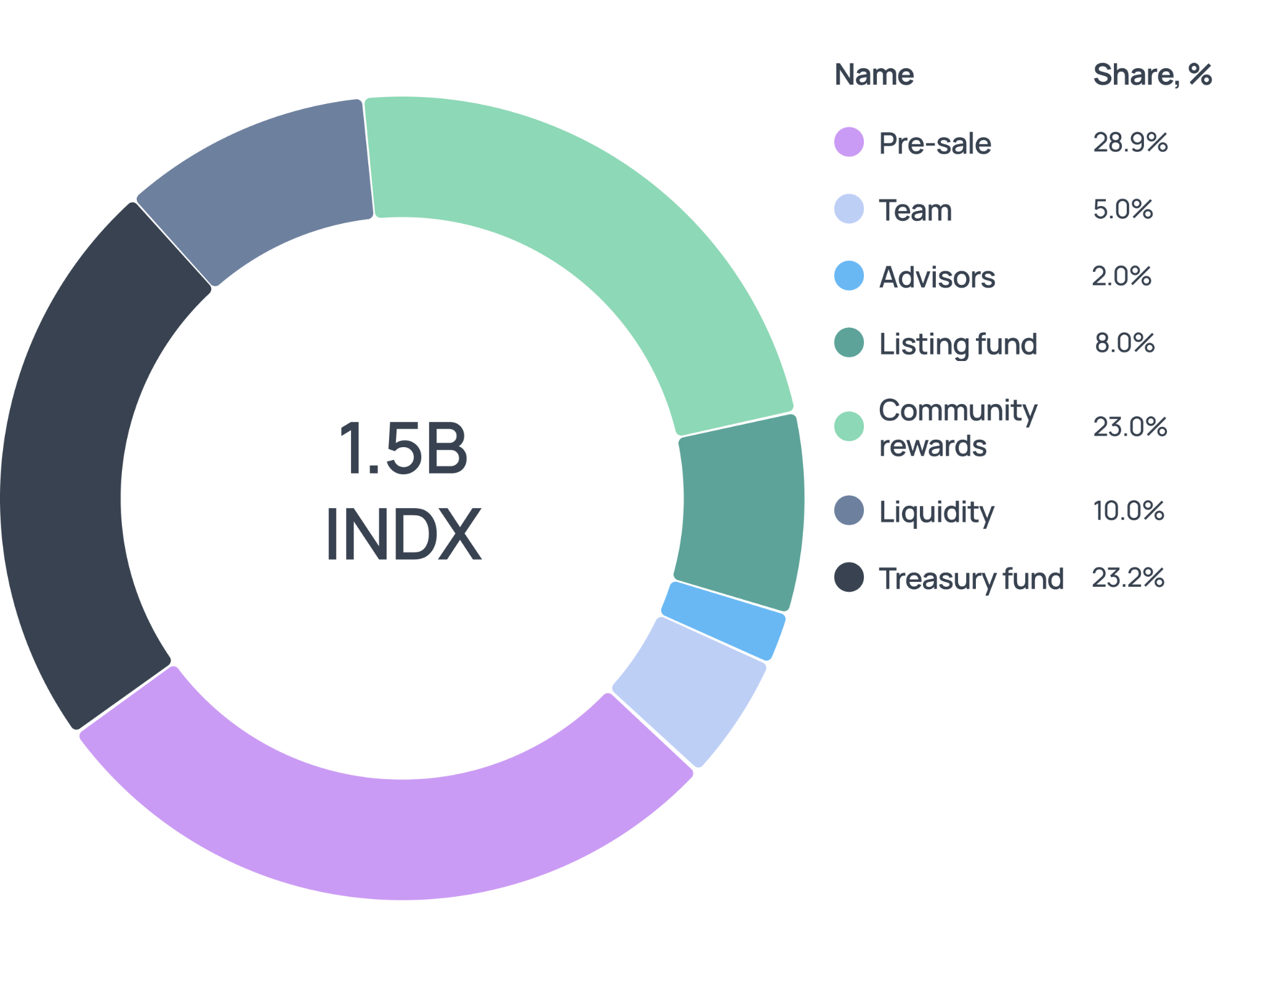
We aim to have the following token allocations, lockup periods, and vesting periods:
Entity | Allocation, % | Allocation,  tokens | Unlock at TGE, % | Lockup period, mo** | Vesting period, mo
Pre-sale* | 28.9% | 433.5M | 5.0-10.0% | 2-6 | 6-12
Team | 5.0% | 75.0М | - | 12 | 24
Advisors | 2.0% | 30.0M | - | 6 | 18
Listing Fund | 8.0% | 120.0M | - | - | -
Liquidity | 10.0% | 150.0M | - | - | -
Community Rewards*** | 23.0% | 345.0M | - | - | 32
Treasury Fund**** | 23.1% | 346.5M | - | - | 48
Total | 100.0% | 1,500.0M | 21.9%
Table 1. INDX Token Allocations, Unlock at TGE, Lockups, and Vesting
* The duration of the lockup period and vesting period for Pre-sale tokens is determined by the purchasing conditions (shorter lockup period and vesting for later purchases). Moreover, the unlock at TGE for Presale tokens also differs based on the period of purchase (greater share for early purchases). However, the lockup period begins for all Presales at the moment of TGE.
** The lockup duration is not included in the vesting timeframe, so the full allocation will be unlocked after the lockup and the vesting period
*** Tokens from the community rewards category will be distributed as rewards to users within the incentivization program, referral program, and other irregular reward distributions to users (seasonal rewards).
****Tokens from the Treasury fund category will be distributed for future development and platform improvement.

Core Utility of INDX
The primary goal of the INDX token is to promote the long-term development of the Cryptoindex protocol. This is made possible by satisfying the interests of all stakeholders, as well as fairly rewarding them.
To achieve this goal, Cryptoindex has developed a utility of a single token that facilitates their interactions, maximizing the value obtained:
- Index Creators: By creating indexes through the protocol, creators receive a percentage of income in INDX tokens from exit, entry, and management fees paid by users for interacting with their indexes, as well as seasonal rewards.
- Index Buyers: By purchasing indexes, users not only benefit from the index's performance but also gain the opportunity to receive rewards in INDX tokens through the incentivization program and additional rewards for index holders.
- Liquidity Providers: By creating decentralized pools on DEX that include protocol tokens (INDX, index tokens) and adding liquidity to existing pools, users have the opportunity to receive rewards in INDX tokens through rewards for LPs.
Thus, the INDX token becomes the fuel for securing and maintaining all the core processes of the Cryptoindex platform, as well as a key element of the user incentivization programs.
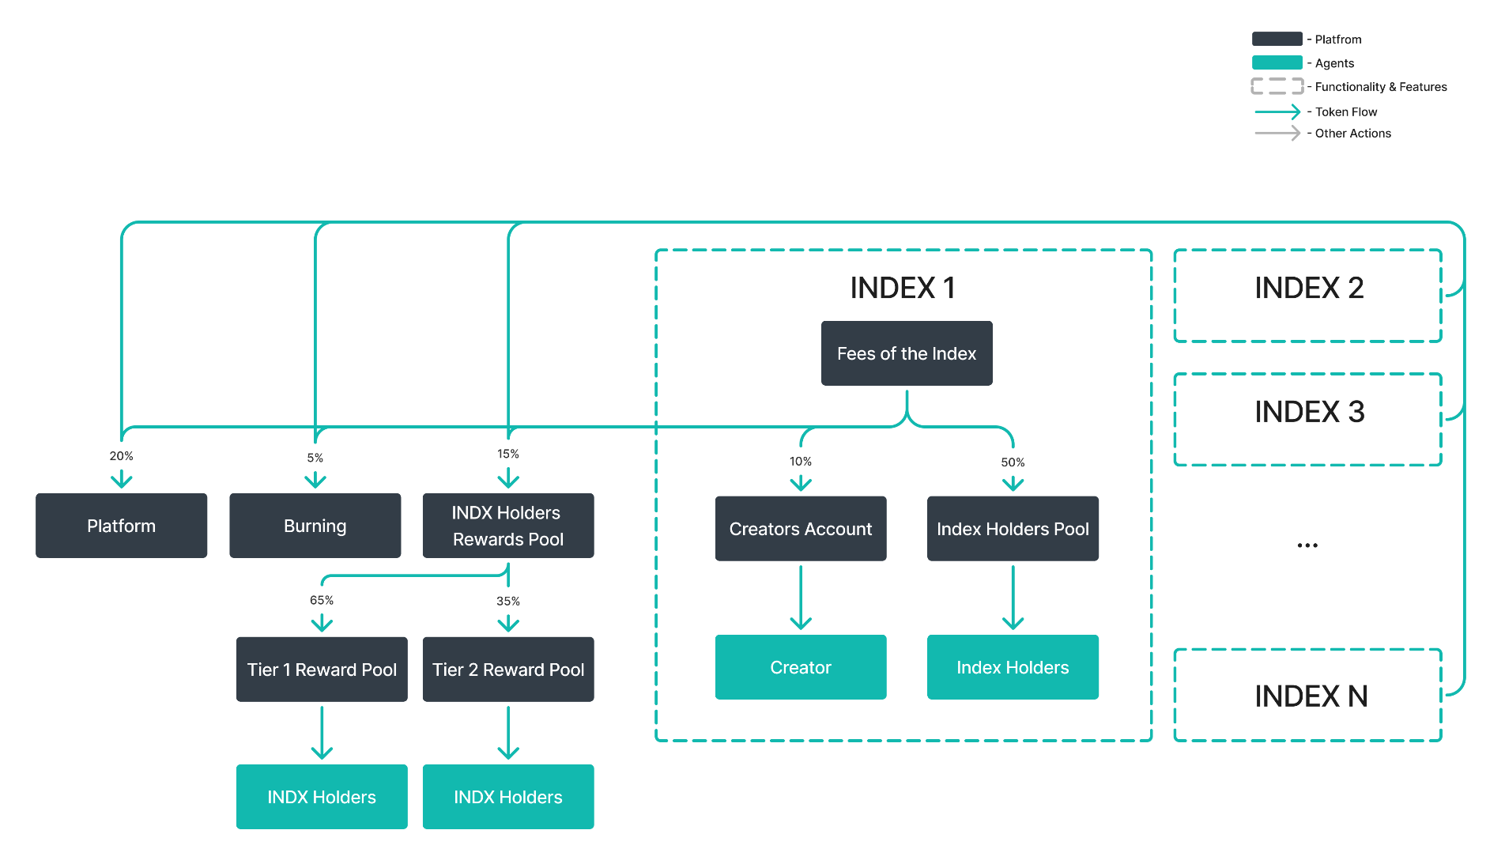
Here is the core functionality for INDX token holders:
- Creators Subscription: To create indexes and perform their subsequent maintenance, the user needs to purchase a subscription for INDX tokens. More detailed information is presented in the Creators Subscription section.
- Entry/Exit Fee: The index creator introduces fees for entering and exiting the index, which the user pays in INDX tokens. More detailed information is presented in the Fee Structure and Index Holders Fees sections.
- Management Fee: The index creator can enter an index management fee, which is charged in INDX tokens. More detailed information is presented in the Fee Structure and Index Holders Fees sections.
- Incentivization Program: To reward long-term users who have shown loyalty and made a significant contribution to the development of the product, the platform has created a special incentivization pool. To become a participant in the incentivization program, a user must lock INDX tokens in the pool. The amount of the reward and the size of the entry/exit fee reduction depends on the type of the pool. More detailed information is presented in the Incentivization Program section.
- Additional Rewards for Indexes Holders: The Cryptoindex platform offers index token holders the opportunity to earn additional rewards in INDX tokens for long-term holding. More detailed information is presented in the Additional Rewards for Indexes Holders section.
- Additional Rewards for LPs: Users can support the platform by providing liquidity to the INDX pools and index tokens, receiving rewards from the platform for doing so. More detailed information is presented in the Additional Rewards for LPs section.

Additional Utility of INDX
INDX functionality is not limited to the use cases discussed in the Core Utility of INDX section. The token can also be used by users in auxiliary functions of the protocol, which extend and supplement the value of the core utilities:
- Advertising Promotion: To attract more attention from users to the index, creators can purchase advertising for INDX tokens. The cost of advertising is variable and is determined based on auction mechanics. More detailed information is presented in the Advertising Promotion section.
- Referral Program: Users referring new participants earn INDX tokens, enhancing user growth and token demand. More detailed information is presented in the Referral Program section.
- Seasonal Rewards: The Cryptoindex platform conducts seasonal events to reward active users by introducing seasonal rewards and bonuses for top-performing index creators to maintain user engagement and participation.

More details about INDX utility

Creators Subscription
To be able to create indexes, as well as their subsequent maintenance, the user needs to purchase a subscription for INDX tokens.
Cryptoindex offers 3 types of subscriptions. The subscription types are distinguished by the maximum number of indexes created, access to different blockchains whose tokens can be included in the index, and amount of fees distributed:
 | Level 1 | Level 2 | Level 3
Price ($ worth in INDX) | $800 | $420 | $150
Amount of indexes available for creation | ∞ | 10 | 5
Available blockchains | 5+ | 3 | 1
Max tokens in one index | 30 | 20 | 15
Available tokens | High, Medium, Low risk | Medium, Low risk | Low risk
Table 2. Creators Subscription
Cryptoindex recognizes that one of the core values of the platform is shaped by the extensive community of index creators. Therefore, the type of subscription also has an impact on the rewards received by the creators. Index creators' rewards are formed by 2 components: entry and exit fees, and management fees.
The detailed distribution of fees allocated to creators is presented in Table 3:
 | Level 1 | Level 2 | Level 3
Percent of entry and exit fees distributed | 15% | 10% | 5%
Percent of management fee distribution | 15% | 10% | 5%
Table 3. Distribution of Fees Based on the Type of Subscriptions for Creators
If the creator does not update his subscription in time, then his income from the indexes is temporarily blocked but continues to accumulate. If enough funds have accumulated during the non-payment period to pay for the subscription, the platform debits the required amount, and subscription privileges become available to the creator again, including the withdrawal of accumulated funds from commissions.

Index Holders Fees
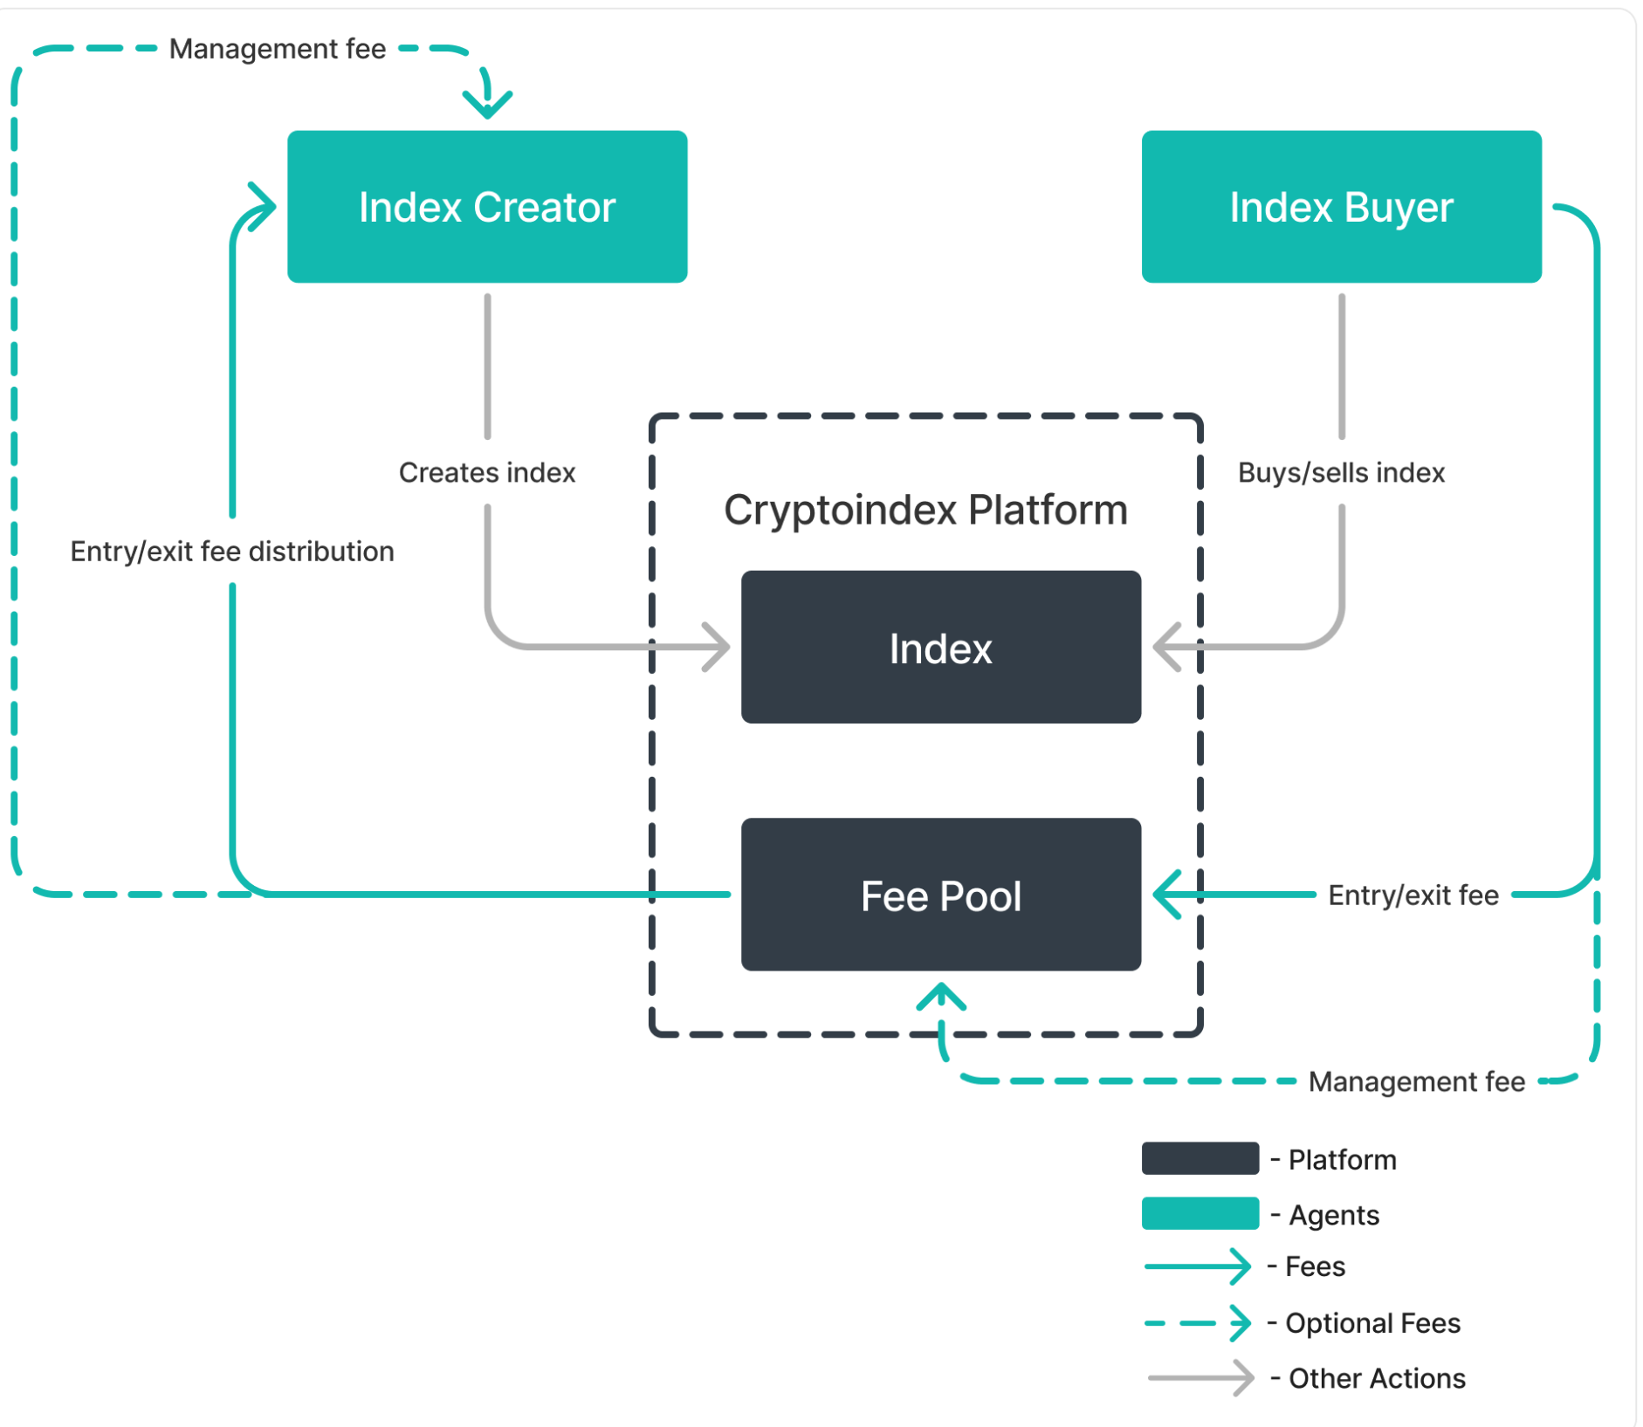
All fees on the platform are presented in the Fee Structure section. This section will discuss in detail the calculation of entry/exit and management fees, which are paid in INDX tokens:
- Entry/Exit Fees: The user pays a fee when entering/exiting the index. This one-time fee ranges from 0.5-5.0% of the position size as determined by the index creator.
- Optional Management Fee: The index creator can introduce a monthly management fee of 0.0-5.0% per annum of the position size or 0.0-20.0% of the profit. This fee is not mandatory and is at the discretion of the index creator.
Below is an example of calculating the accrual of fee:
- Index configuration: The entry/exit fee is 0.5%, and the management fee is 2% per annum from the position size.
Suppose the user Bill enters the index with an amount of $1,000. Assuming the index grows by 5% every month, Bill stays in the index for 1.5 months.
Month | Action | Change of holdings | Balance | Fee | Fee Amount
0 | Initial Capital | - | $1,000.0 | Entry Fee(0.5%) | $5.00
1 | 5% Index Growth | $50.0 | $1,050.0 | Management Fee (0.167%) | $1.75
1.5 | Additional Index Growth 2.5% | $26.3 | $1,076.3 | Management Fee (0.084%) | $0.90
1.5 | Exit | - | $1,076.3 | Exit Fee (0.5%) | $5.40
 |  |  |  | Total Fee | $13.05
Table 4. Balances and Fees Amounts
- Index configuration: The entry/exit fee is 0.5%, and the management fee is 20% of the user’s profit.
Suppose the user Bill enters the index with an amount of $1,000. Assuming the index grows by 5% every month, Bill stays in the index for 1.5 months.
Month | Action | Change of holdings | Balance | Fee | Fee Amount
0 | Initial Capital | - | $1,000.0 | Entry Fee(0.5%) | $5.00
1 | 5% Index Growth | $50.0 | $1,050.0
1.5 | Additional Index Growth 2.5% | $26.3 | $1,076.3
1.5 | Exit | - | $1,076.3 | Management Fee (20.0%) | $15.26
 |  |  |  | Exit Fee (0.5%) | $5.40
 |  |  |  | Total Fee | $25.66
Table 5. Balances and Fees Amounts
By understanding these fee structures and the potential growth of their holdings, users can make informed decisions and manage their costs effectively while benefiting from the services offered by the Cryptoindex platform.

Incentivization Program
To reward long-term holders who have shown loyalty and made a significant contribution to the development of the product, the platform has created a special Rewards pool. In order to become a participant in the rewards program, a user must lock INDX tokens in the specific pool.
Participation in the rewards program offers token holders the following benefits:
- Reduced entry & exit fees.
- Reward in INDX tokens.
Incentivization program rewards are distributed from the Community rewards allocation.
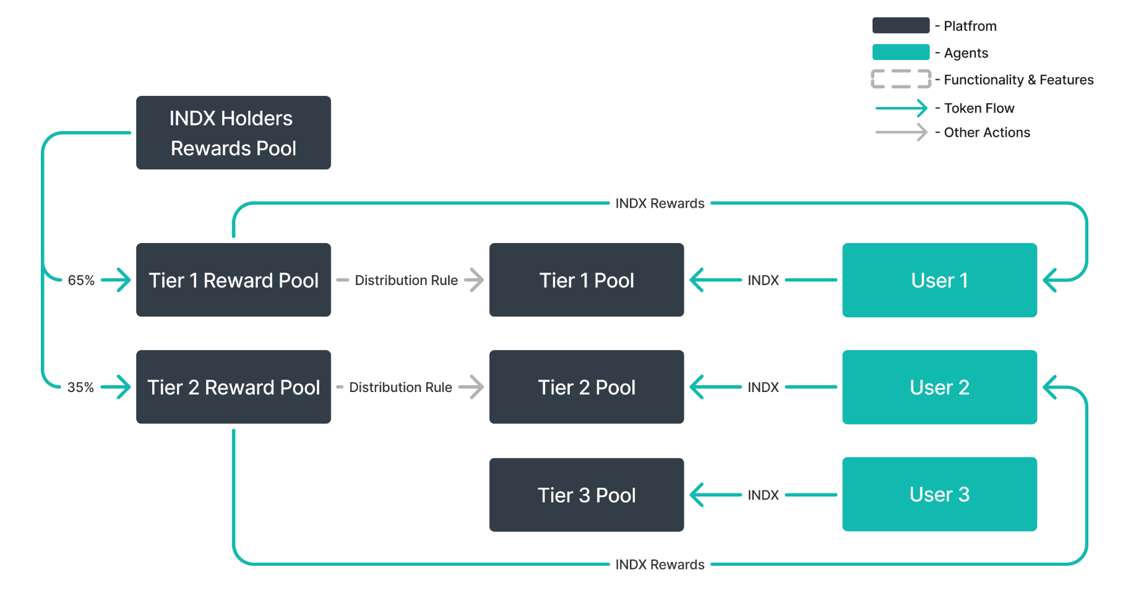
There are a total of 3 types of pools on the platform. The types differ among themselves in the minimum size of the locked tokens, the level of commission reduction, and the percentage of allocated rewards:
Tier number | Locked amount ($ worth in INDX) | Discount (entry/exit fees) | Tier_{k} (% of rewards pool)
Tier 1 | 10.0K+ | 50.0% | 65.0%
Tier 2 | 1.0K-10.0K | 40.0% | 35.0%
Tier 3 | <1.0K* | 25.0% | -
Table 6. Incentivization Program
* The minimal locked amount is $100 worth in INDX
Locking occurs based on epochs. Each epoch lasts for a week. If users decrease their locked amount during an epoch, they decrease the rewards they would have received.
Rewards are distributed at the end of each epoch based on the amount of tokens locked and the length of time they were locked. By following the rules of the incentivization program and keeping tokens locked until the end of the epoch, users can expect to be fully rewarded:
$User's reward per epoch = Reward pool per epoch ×{Tier}_{k} ×\frac{\sum_{i=1}^{7}{}min( User's active INDX amount)}{\sum_{i=1}^{7}{}min ({Total users active INDX amount}_{k})}$
Where:
- $User's reward per epoch$ - rewards that a specific user will receive per week when locking a certain amount of INDX tokens into a specific Tier $k$ pool
- $k$ - Tier number, $kϵ[1,3]$
- $Reward pool per epoch$ - rewards distributed from the reward pool each week
- ${Tier}_{k}$ - percentage of the $Reward pool per epoch$, which is distributed depending on the Tier of the lock, according to Table 3.
- $\sum_{i=1}^{7}{}min( User's active INDX amount )$ - the sum of the daily minimum active INDX amount locked for a week
- $\sum_{i=1}^{7}{}min ({Total users active INDX amount}_{k})$ - the sum of the daily minimum active INDX amount locked among all users in the Tier $k$ for a week
Below is an example of how rewards are calculated for a user participating in the incentivization program:
User John has 5K INDX (1 INDX = $1) in his account. John chooses a pool based on the number of tokens he plans to lock up - 5,000 INDX (if 1 INDX = $1). He deposits his tokens into the Tier 2 pool (1,000 - 10,000 INDX).
Available Benefits:
- Reward Pool: Let's assume the reward pool is 1,000 INDX for the week.
- Tier 2 Allocation: The Tier 2 pool accounts for 35% of the total reward pool. Therefore, Tier 2 is allocated 350 INDX (1,000 INDX * 35%).
- John's Share: The total tokens in the Tier 2 pool remained at 50,000 INDX during the week, with John contributing 10% of this amount (5,000 INDX / 50,000 INDX). As a result, John receives 10% of the Tier 2 rewards, which equates to 35 INDX (350 INDX * 10%).
- Discounted Fees: During the week, John buys an index for $1,000. As a Tier 2 participant, he is eligible for a discounted entry fee. Instead of paying the standard 2% entry fee ($20), he pays a reduced fee of 1.2% ($12), thanks to the 40% discount available to Tier 2 participants.
The implementation of a multi-tiered motivation system will allow token holders to gain additional benefits from owning indexes, while the protocol will establish a long-term user base.

Additional Rewards for Index Holders
The Cryptoindex platform is primarily a cohesive community of token creators and holders. Only with the attention from users and their support Cryptoindex platform can create value for the Web3 space, grow, and expand its influence to a larger audience.
Recognizing the importance of the community, the Cryptoindex platform has created a separate reward program for index holders. This program expands the benefits for index holders, comprising 2 components:
- Primary value (actual change in the index value over a period).
- Additional value from long-term index holding.
Below is more detailed information on the formation and distribution of the additional value component.
To be eligible for additional value, users need to lock their index tokens in a lock smart contract. These locked tokens can be used for voting on index rebalancing issues.
Rewards are distributed in INDX tokens. The allocation size for each index is determined proportionally by the amount of fees paid by users within each index. It means that only fees of this index are allocated to the holders of a particular index.
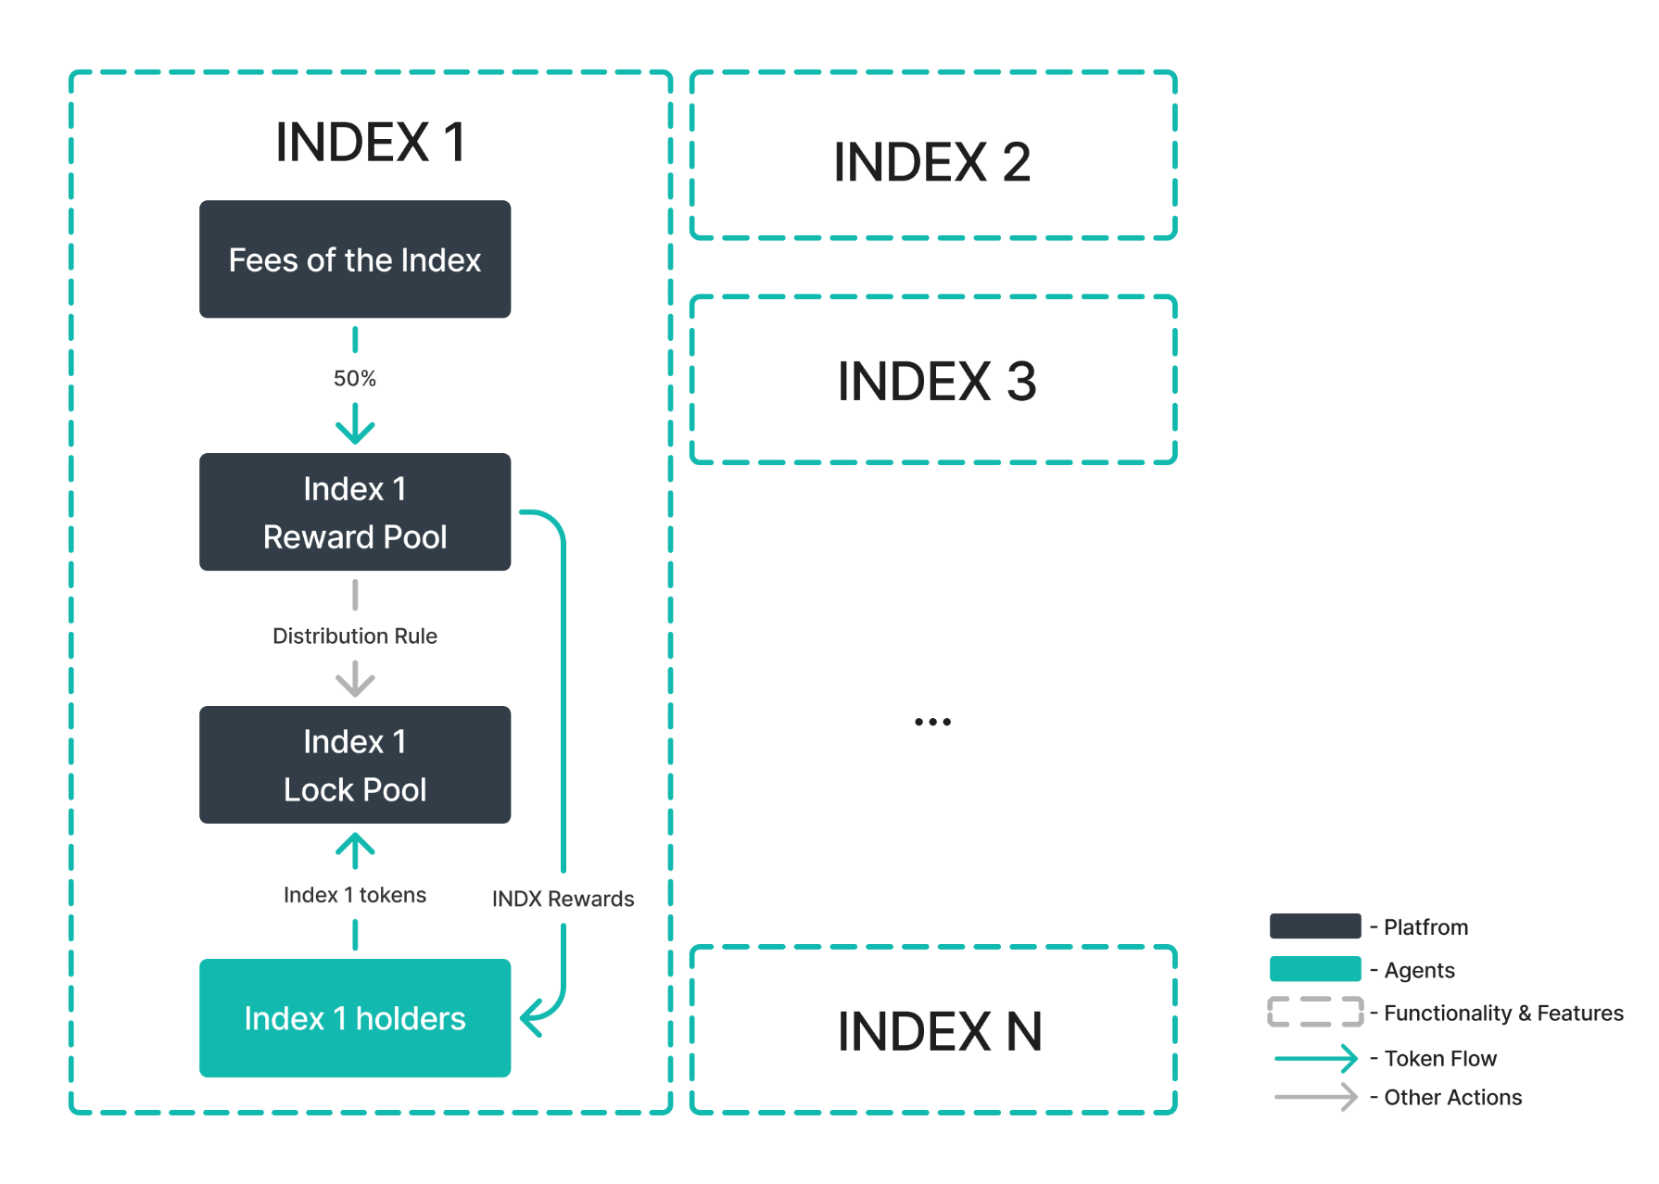Rewards are distributed at the end of each epoch (1 week) based on the number of locked tokens and the duration for which they were locked. By following the incentive program rules and keeping the tokens locked until the end of the epoch, users can expect to receive the full reward:
$User's reward per epoch = Reward pool per epoch×\frac{\sum_{i=1}^{7}{}min( {User's active index token amount}_{})}{\sum_{i=1}^{7}{}min ({Total users active index token amount}_{})}$
Where:
- $i$ - day number of the epoch, $i ϵ [1,7]$
- $User's reward per epoch$ - rewards that a specific user will receive per week when locking a certain amount of index tokens
- $Reward pool per epoch$ - rewards distributed from the reward pool to the index each week
- $\sum_{i=1}^{7}{}min( User's active index token amount )$ - the sum of the daily minimum active index token amount locked for a week
- $\sum_{i=1}^{7}{}min ({Total users active index token amount}_{})$ - the sum of the daily minimum active index token amount among all users in indexes locked for a week

Additional Rewards for LPs
Cryptoindex aims to democratize index access for the entire cryptocurrency space in an effort to expand its influence beyond the platform. One possibility to achieve this goal is the creation and use of decentralized pools.
Decentralized liquidity pools will stimulate initial interest from users to try the product, so the platform has developed an incentive program designed for the creators of such pools and liquidity providers.
Cryptoindex will incentivize the following decentralized pools in the first phase of the program:
- INDX/USDT pool.
- The pool of “base indexes” created by the platform in pairs with INDX.
The list of pools will be updated thereafter. Up-to-date information about the incentive program will be provided on the platform's website.
Tokens for the incentivization program are distributed from the Community Rewards allocation. The distribution of tokens by year is presented in Table 7:
 | Year 1 | Year 2 | Year 3 | Total
Yearly LP Pool (Amount of tokens distributed) | 16.0M | 8.5M | 5.5M | 30M
Table 7. Tokens distribution schedule for the LP program
Within the year, tokens will be allocated by month according to the function below:
${Monthly LP Pool}_{i} ={Yearly LP Pool}_{k}×\frac{100/i^{0.25}× e^{-0.015i}}{\sum_{i=12k-11}^{12k}{}100/i^{0.25}× e^{-0.015i}}$
Where:
- $i$ - month number, $i ϵ [1,36]$
- $k$ - year number, $k ϵ [1,3]$
- ${Monthly LP Pool}_{i}$ - the number of tokens that are distributed equally during the month.
- ${Yearly LP Pool}_{k}$ - number of tokens that are distributed in total during the year, according to Table 7.
- $\frac{100/i^{0.25}× e^{-0.015i}}{\sum_{i=12k-11}^{12k}{}100/i^{0.25}× e^{-0.015i}}$ - function, which stipulates that liquidity providers will be incentivized more at the beginning of the project cycle.
More information on the distribution of tokens under the incentive program by month is provided in the graph below:
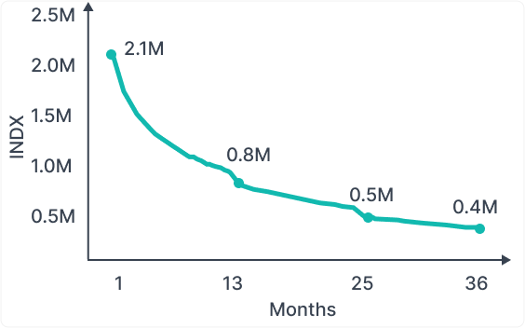
The actual distribution of allocation to specific pools is made on the basis of the platform's decision. Within pools, funds are distributed to liquidity providers in proportion to their share in the pool.
After the distribution of rewards, over the course of 36 months, additional funds for rewards will be sourced by the protocol through a buyback mechanism.

Advertising Promotion
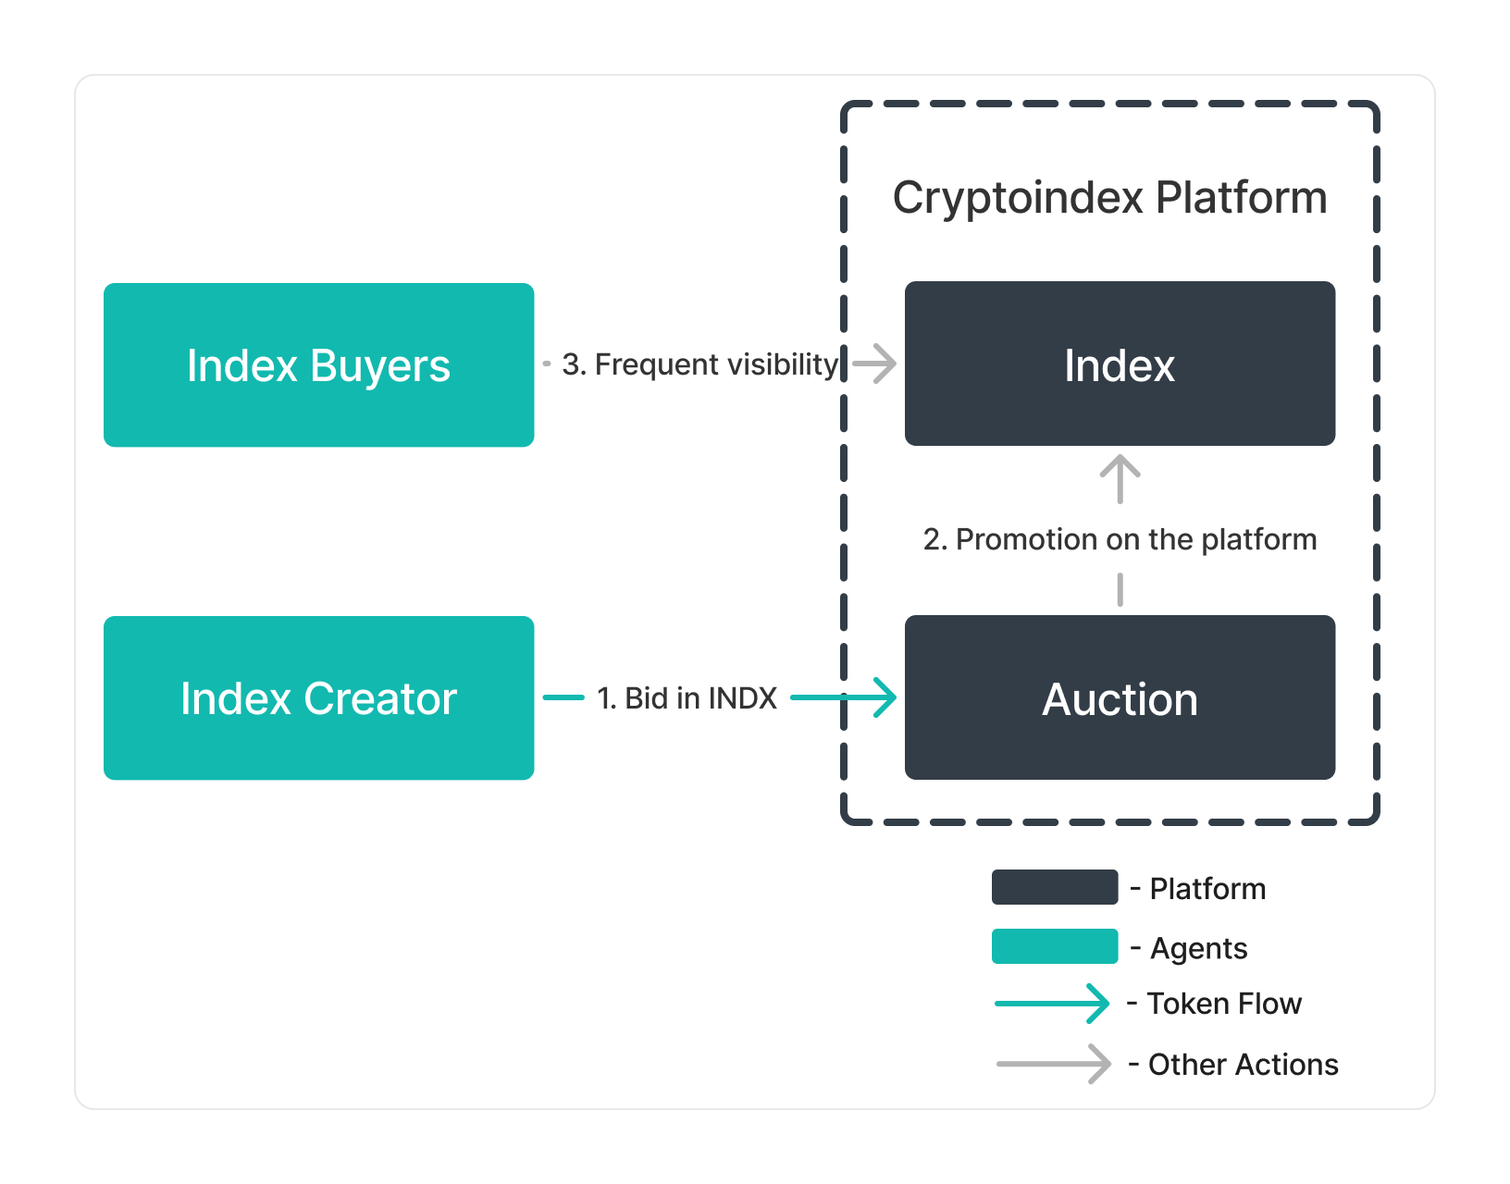
To draw more user attention to their indexes, creators can purchase advertising using INDX tokens. This feature is designed to enhance visibility and attract potential buyers to specific indexes. The advertising mechanism operates as follows:
- Auction-Based Pricing
  - Base Price: The platform sets a base price for advertising slots to establish a starting point for bids.
  - Bidding Process: Creators submit bids in INDX tokens, competing with one another for the advertising slots. The final price is determined by the highest bid, ensuring a dynamic and competitive pricing environment.
- Advertising Slots
  - Time-Limited: Advertising slots are available for specific time periods, such as daily, weekly, or monthly durations. This ensures that promoted indexes receive concentrated attention during the chosen timeframe.
  - Visibility: Advertisements are prominently displayed on the platform, reaching a wide audience of potential buyers.
- Payment and Execution
  - INDX Tokens: All payments for advertising are made exclusively in INDX tokens, integrating seamlessly with the platform’s ecosystem.
  - Automated Process: Once a bid is accepted and the payment is made, the advertising campaign is automatically scheduled and launched according to the specified time period.

Referral Program
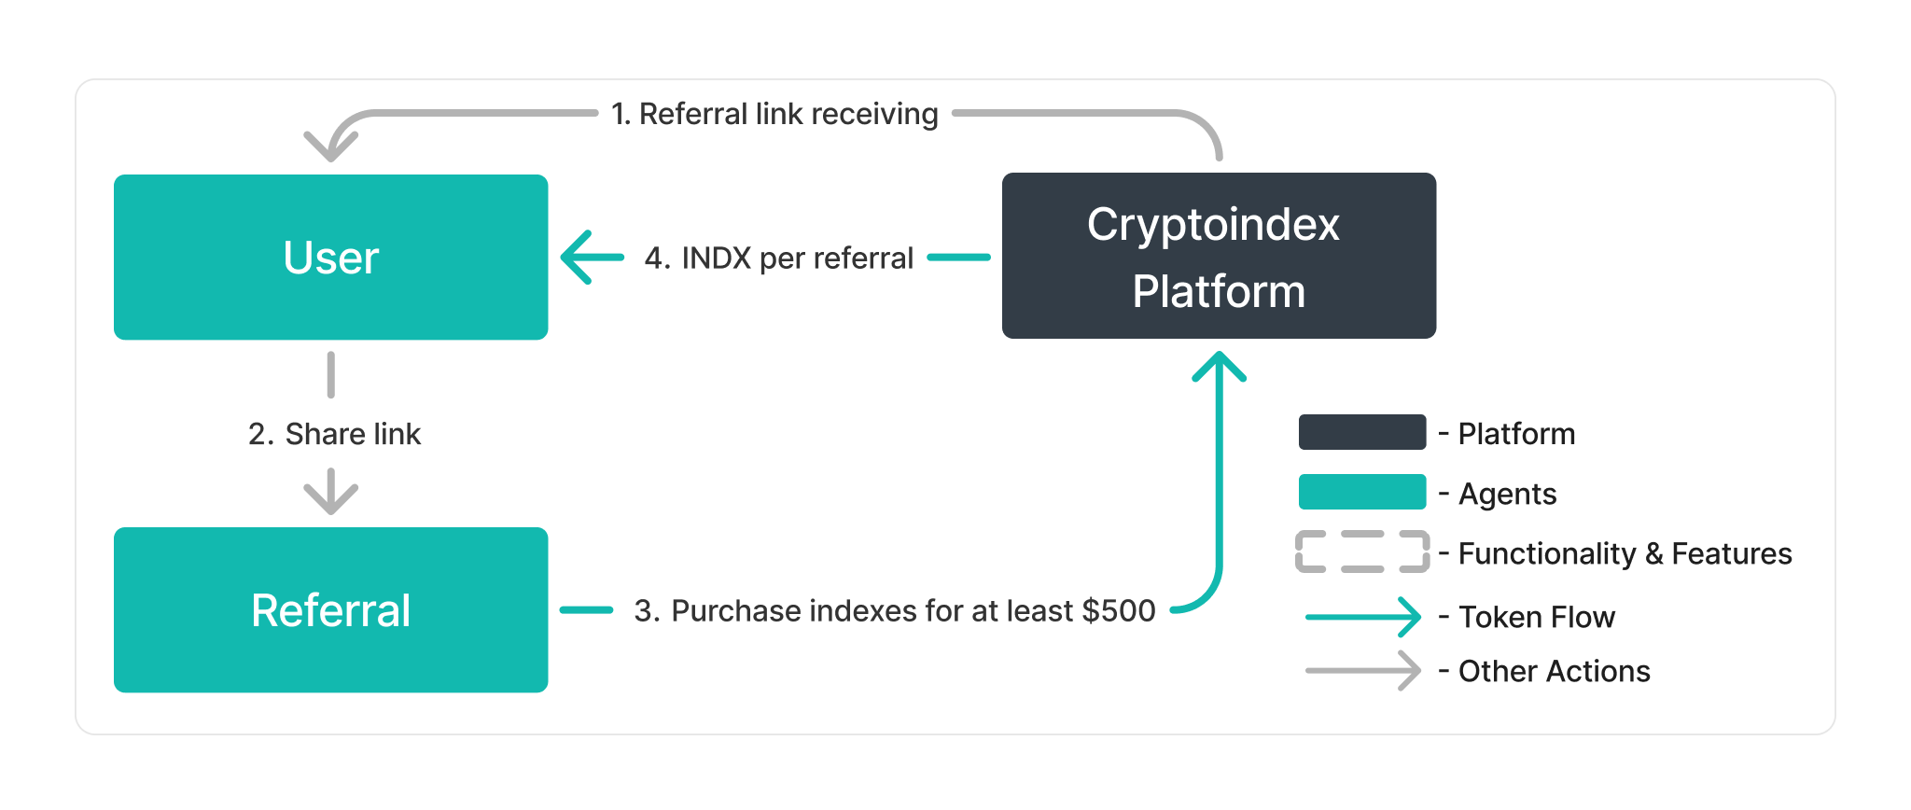
The Cryptoindex platform encourages user growth and engagement through its Referral Program. This program is designed to reward users who invite new participants to join and actively use the platform, fostering a community-driven expansion:
- Referral Link Generation:
  - Personalized Links: Each registered user receives a unique referral link, which can be shared with friends, family, and social networks.
  - Tracking Referrals: The platform tracks the activity of new users who register using the referral link, ensuring accurate attribution of rewards.
  - No Limits: Users can invite an unlimited number of referrals to the platform, maximizing their potential rewards.
- Referral Rewards
  - Reward Structure: Referrers earn INDX tokens as a reward when their referrals purchase indexes on the platform.
  - Purchase Requirement: To qualify for referral rewards, the referred user must buy indexes totaling at least $200.
  - One-Time Reward: The reward is granted as a one-time bonus when the minimum purchase requirement is met. Referral rewards are distributed from the Community rewards allocation.

Burning
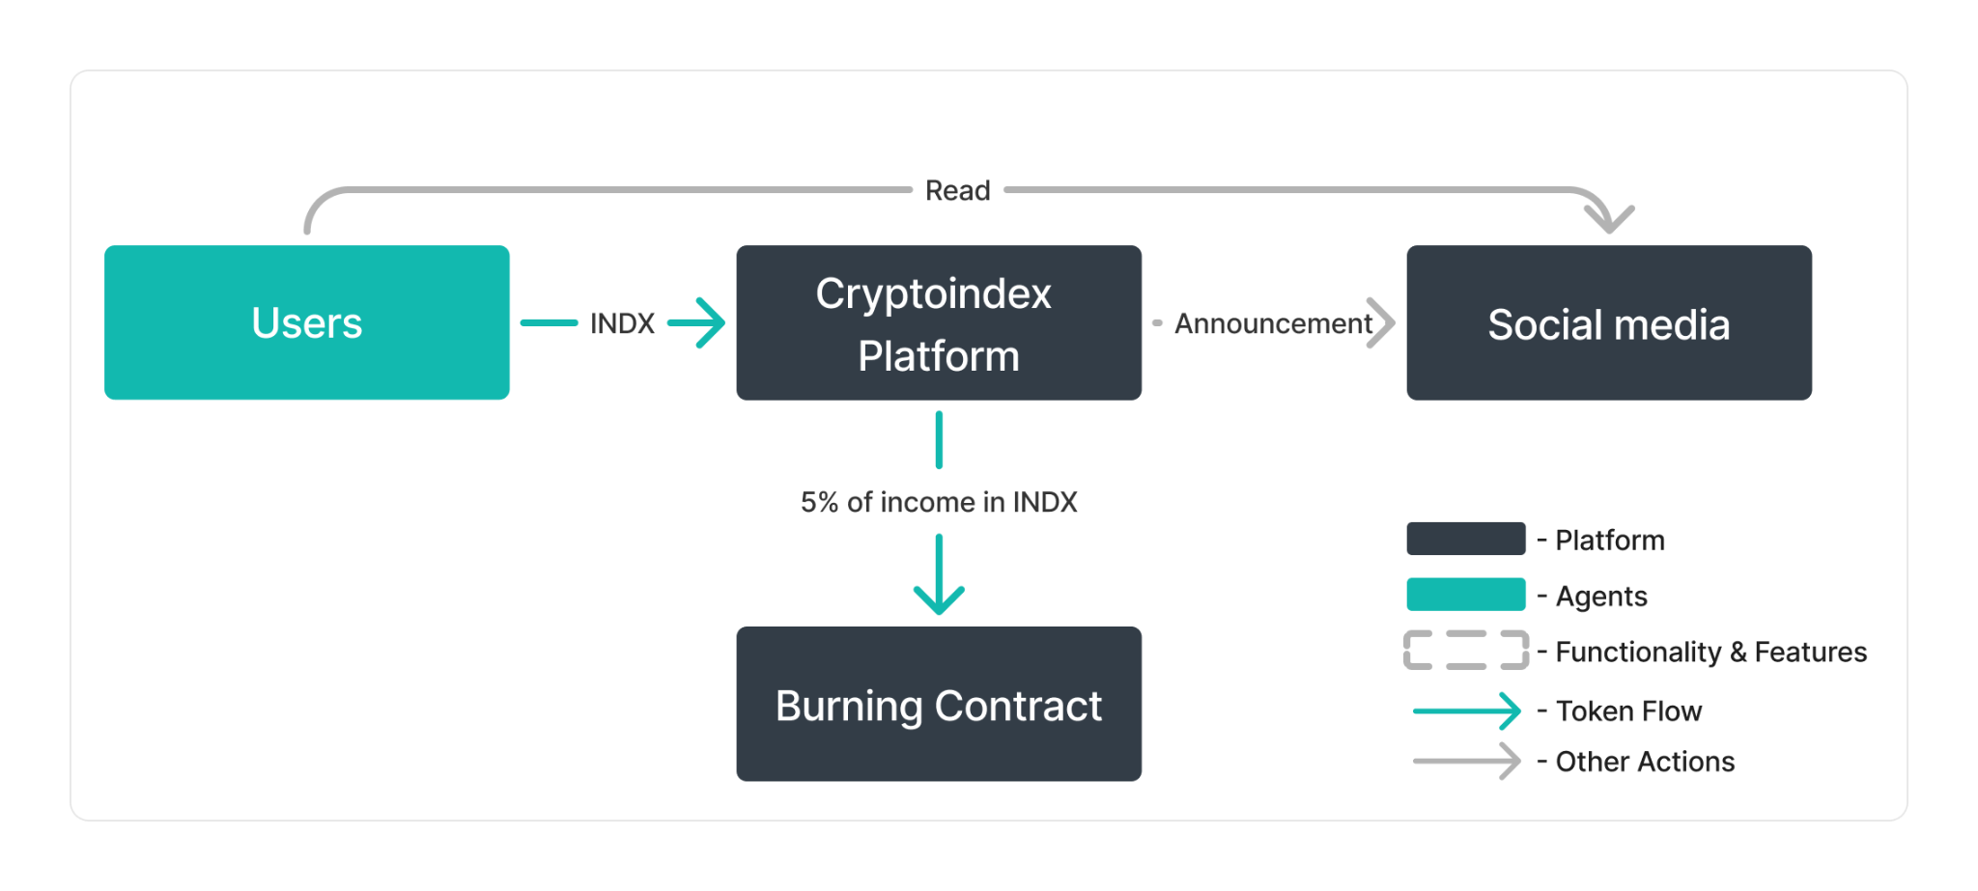
Burning is a strategic mechanism employed by the Cryptoindex platform to maintain and enhance the value of the INDX token by reducing its total supply over time:
- Percentage of Net Profit Allocation:
  - Percentage: The platform allocates 5.0% of its net profit to token burning.
  - Purpose: This allocation aims to regularly reduce the circulating supply of INDX tokens, contributing to an increase in their scarcity and, potentially, their value.
- Burning Regularity:
  - Frequency: Tokens are burned on a monthly basis.
  - Procedure: At the end of each month, the platform calculates the net profit and allocates 5.0% of this profit to buy back INDX tokens from the market. These tokens are then permanently removed from circulation by sending them to a null contract address, ensuring they can never be retrieved or used again.
- Transparency and Reporting:
  - Public Announcements: Every burning event will be publicly announced through the platform's official communication channels.
  - Burn Reports: Detailed burn reports will be published after each event, outlining the number of tokens burned, the transaction details, and the updated circulating supply of INDX tokens.

4. Security
Cryptoindex recognizes the importance of the safe use of crypto platforms and strives to give users confidence and peace of mind when using our platform and interacting with the web3 world. Within our platform, we implement the following measures:
- Use of smart contracts: Utilizing smart contracts enhances user security through decentralization, transparency, immutability, automation, and funds protection on the blockchain. Smart contracts ensure secure contract execution, prevent fraud, and provide reliable storage of user funds.
- Internal security audits: Regular security audits help identify and address potential vulnerabilities in the system, ensuring a high level of protection for user funds.
- Monitoring and alerting: Implementing real-time monitoring and alerting systems helps detect suspicious activities and potential security breaches, allowing for quick response and mitigation.

5. Risks
Interacting with a cryptocurrency platform comes with a number of specific risks for the user, including high market volatility, technical flaws, and regulatory challenges. These risks can be reduced through a comprehensive risk assessment and contingency planning.
- Cybersecurity risks: Cryptocurrency platforms are an attractive target for cybercriminals due to the significant financial assets stored on these platforms. Attacks can be aimed at stealing cryptocurrency, gaining access to personal user data, or even disrupting the platform itself.
- Malware: A virus-infected computer or smartphone is a common cause of loss of cryptocurrency. If the victim uses a wallet, the criminals can steal the private key and perform transactions to empty the wallet.
- Asset loss risks: Cryptocurrencies are stored in digital wallets, access to which is granted through private keys. Losing the private key or access to the wallet can result in the complete loss of funds with no possibility of recovery.
- Technical malfunction risks: Technical issues such as system crashes, service unavailability, and scalability problems can significantly impact the operation of a cryptocurrency platform.
- Underlying blockchain risk: The possibility of a blockchain network failure or malfunction can pose a serious threat to the protocols you access through this offering. Such failures could lead to loss of access to your assets, transaction delays, or even funds loss.
- Legal uncertainty: Many aspects of blockchain technology and related services are not clearly regulated by law. Users face uncertainty and risk due to potential changes in rules and requirements, which can affect their use of services, restrict access, or pose potential liability.
- Market volatility risks: Cryptocurrency prices fluctuate significantly and can change rapidly. This poses a risk for platform users as asset prices can sharply decrease or increase, resulting in losses or profits.
- Risk of insufficient liquidity: Insufficient liquidity in index token pools can cause significant price drops, increased volatility, and difficulties in executing trades at desired index token prices.
Understanding and being aware of these risks will help users of cryptocurrency platforms make informed decisions and take action to ensure the security of their cryptocurrency funds.

6. Project Roadmap
Months after Launch | Event
First Launch | Fair launch of the INDX token
2 Months | Platform beta launch on BNB and Ethereum
2 Months | Launch of the Incentivization program
3 Months | Expansion to BASE bloсkchain
3 Months | Secret partnership announcement
6 Months | TVL reaching $100M
6 Months | INDX listing on CEX and DEX platforms
9 Months | Leveraged index trading beta
9 Months | Governance introduction
12 Months | TVL reaching $1M
12 Months | Introduction of index insurance
12 Months | Launch of mobile app
15 Months | Global marketing campaign
15 Months | 3500 indexes created, 500 active indexes
18 Months | Index-based ETF negotiations
Table 8. Project Roadmap

7. Legal Disclaimer
This paper is not an advertisement or promotion for investing activity, nor is it an offer to buy or sell any INDX tokens. It is not a reliable source for any kind of advice, including financial or legal advice. The information is based on fictitious numbers that could change, and there are no guarantees about its accuracy. This information is subject to change at any time.

S&P 500
Coingecko
DefiLlama
DefiLlama

