ESD damage
ESD damage is a phenomenon that can occur when electrical charges are present in the air. These charges can be caused by static electricity, which occurs when a material becomes electrically charged because of some external force, or explosive discharge, which occurs as a result of an explosive device's detonation.
What is ESD damage?
ESD damage is a type of electrical short. It's caused by a build-up of static electricity on the surface of your device and can be caused by everyday activities like touching your smartphone when it's charging or rubbing your hands on your clothing.
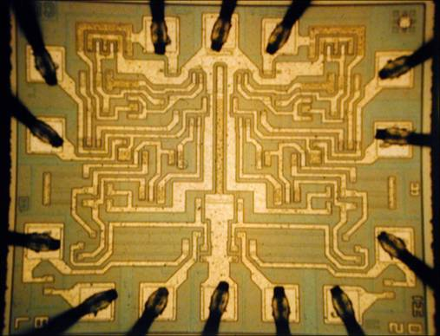
What is ESD in SMT?
ESD is a type of electrical discharge that can occur between two objects with differing charges. This can happen when one object is grounded and another is not, or a large amount of static electricity builds up on the surface of an object and then suddenly dissipates into another object.
This can cause problems for SMT because SMT components are held down by solder bumps, which have a charge of their own. If the bumps have no charge, they can attract static electricity from ESD and create more problems than they solve.
How ESD affect PCB?
Electrostatic discharge (ESD) can be a serious problem for PCBs. It is caused by the buildup of static electricity on the surface of a component, which can then be transferred to other components or even the PCB itself when it is touched. ESD destroys electronic components and causes damage to wiring as well.
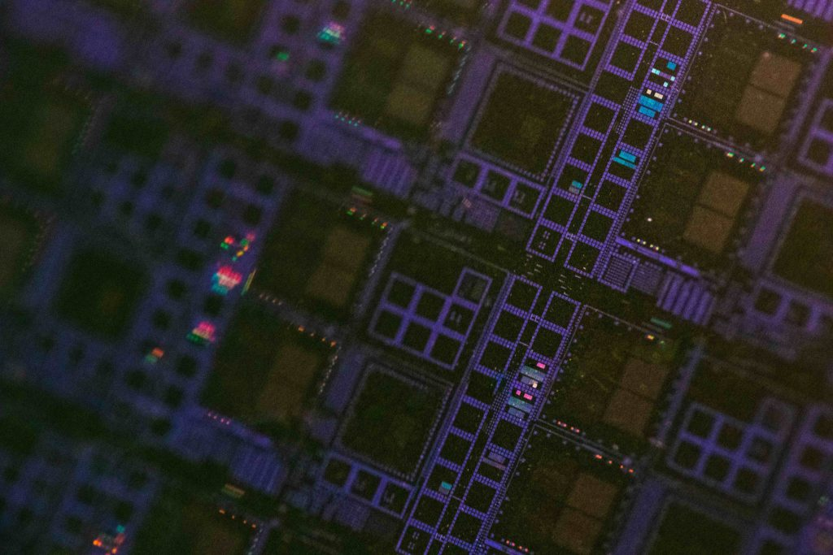
There are several ways that ESD can affect a PCB:
- It will damage the insulation on wires and capacitors, which may cause leakage and short circuits in your system.
- The static buildup will cause cracks in solder joints between components or connectors, which can lead to intermittent or permanent failures of the device.
- If ESD builds up on a component's surface long enough, it can actually lift off part of its silver paste coating layer! This leaves bare copper underneath, which will oxidize quickly if left exposed to air—which could result in corrosion or worse yet: bare conductive surfaces!
What are two types of damage that can be caused by ESD?
Catastrophic failures are the most common type of ESD damage. They happen when static electricity builds up in the air between two objects, causing them to touch each other. This can happen when you touch a grounded object to a non-grounded object, such as your phone touching your shirt.
Latent defects are also common types of ESD damage. Latent defects are defects that are not visible when an item is assembled but become visible after assembly has begun. Latent defects include cracks in the solder joint between parts, or small scratches on parts' surfaces.
What can contribute to ESD damage?
The most common factors causing ESD damage are static electricity and humidity.
Static electricity is when your body creates an electrostatic charge by rubbing together two dissimilar materials. This can happen when you touch a metallic object, such as a screwdriver or computer keyboard. It can also occur when there's friction between two surfaces that are made of different materials—like your shoelaces rubbing against each other as you walk.
Humidity is when there's moisture in the air around you that evaporates into water vapor and forms a cloud of water vapor molecules at the surface of your skin or in the air near your skin. This increases your body's ability to create static electricity because it makes it harder for those molecules to escape into the air through evaporation.
Is ESD damage permanent?
YES, ESD damage is permanent!
ESD damage is like a scar that you can't see—but it's there, lurking in the shadows of your electrical equipment. If you leave ESD damage untreated, it can cause problems for years to come. Even if you've cleaned up an ESD mark on your device, it's still possible for the mark to cause problems as time goes on.
How can ESD damage be prevented?
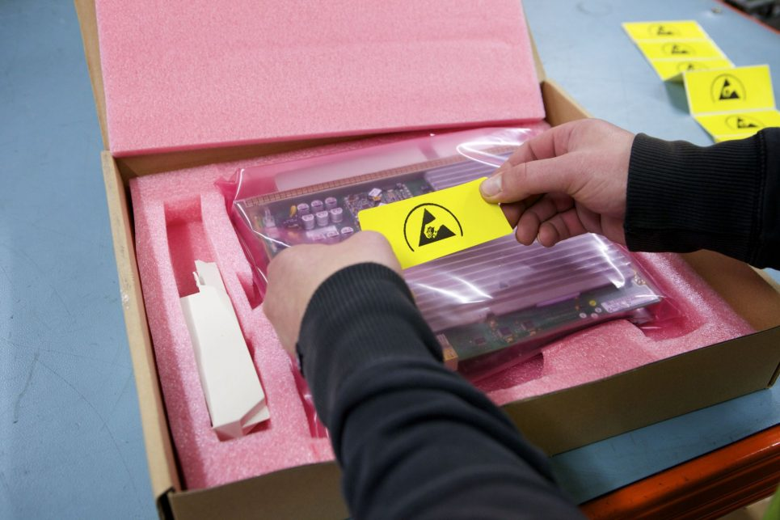
ESD damage can be prevented by taking following precautionary measures.
Don't touch anything with your bare hands.
If you do, wash them before touching anything else!
Avoid touching terminals that are not designed to be touched by humans (like the control panel on a machine) or machines that are designed to be touched by humans (like the buttons on a phone).
If you must touch a terminal, use rubber gloves and keep your fingers away from the edges of the terminal.
Basic ESD requirements of SMT assembly workshop
The following are basic ESD requirements for SMT assembly workshops:
- The workshop should be located in a place that is free from electromagnetic interference.
- The workshop should have a clean and dry environment, with good ventilation.
- You must have an ESD control plan in place, including steps to take when someone has an ESD incident.
- All electrical parts should be properly grounded to eliminate any potential electric shock hazards.
What is the difference between ESD and antistatic?
Antistatic and ESD are two terms that often get used interchangeably, but they're actually quite different.
ESD stands for electrostatic discharge, which is the kind of static electricity that can cause damage to electronics and other sensitive equipment if it builds up inside them. Antistatic is a material that prevents static from building up inside electronic devices, so these devices remain safe from ESD damage.
FAQ about ESD damage
What is ESD voltage?
ESD voltage is not a thing. It's a term used to describe the amount of electricity that flows through your body when you touch something metal.
ESD voltage is also called "electrostatic discharge," and it can be dangerous when it happens in an uncontrolled environment. When you're working on a circuit board, and your body touches the metal surface of the board, you are exposed to this dangerous voltage.
What components are ESD sensitive?
1. Laptops: ESD is the most common cause of laptop failures, and it can strike at any moment. The best way to protect your laptop from ESD damage is to always use a compatible case and keep it in an environment that doesn't generate static electricity.
2. Printers: Printers are also susceptible to ESD damage, so you'll want to take extra precautions when setting up your print jobs. Be sure not to have any metal objects close by while you're printing.
3. Microphones: Microphones are prone to static-electricity damage as well, so be careful when handling them or placing them in close proximity to other electronics.
4. Cameras: Cameras are extremely sensitive to static electricity, especially if they're connected directly to a computer via USB or HDMI cables—both of these ports will generate a lot of static electricity during use.
How does ESD damage electronics?
ESD damage to electronics can happen in a variety of ways and from a number of different sources. The most common way that ESD can damage electronics is by inducing direct current (DC) into the device, which causes it to fail. This can happen when you touch the device with ESD-sensitive components like a finger or an ESD mat, or place the device on an ESD-sensitive surface.
Another common cause of ESD damage is electrostatic discharge (ESD), which is generated when there are no conductive paths to the ground.
Conclusion
The ESD damage can be a serious issue for any business. It is important for companies to be aware of the potential problems that can arise when an employee leaves their desk, or when they have to work in a dirty environment.

