All In One SEO Plugin (AIOSEO) Review – The Best WordPress SEO Plugin?

Meta Description: Are you looking for Best SEO Plugin for WordPress Website? Then Please try the All In One SEO Pack for Best Search Engine Optimization on your website. If you wish to get more information, please scroll down to the bottom of this article.

Introduction

Search engine optimization (SEO) is a crucial aspect of any website. If you don’t have an SEO strategy, your website will never rank high on Google search results. However, finding the best WordPress SEO plugin among the many options available can be complex l also need to know how each plugin works to decide which one is right for you and your business needs.
The All In One SEO Plugin has been around for a long time, but it remains one of the best WordPress plugins for optimizing your site’s content and performance on search engines like Google or Bing.
In this review, we will highlight the critical aspects of AIOSEO but before that, let’s answer why SEO is essential.

Does Your Website Need an SEO Plugin?

You’re here because you want to know what SEO is and why you need an SEO Plugin. Well, let me tell you!
SEO stands for Search Engine Optimization. It’s a way of optimizing your website so that search engines like Google and Bing can find it more easily. A plugin is one of those little things that help your website work better, faster, and more efficiently. SEO plugins will help your website rank higher on search engines such as Google and Bing by improving the following factors:

- Content quality – making sure your content is practical, relevant, and original
- Keyword usage – using keywords in the right places on-page (for example, headings) as well as off-page (links) will help boost rankings in search engine results pages (SERPs). On top of that, using synonyms or niche-related keywords will also improve rankings when combined with other factors like backlinks, etcetera.* Site speed – having fast loading times isn’t just good practice but improves user experience, which leads directly into…* User experience -….and this day, user experience matters most! A slow site means users are less likely to stay engaged with your site long enough through browsing/reading, etcetera, which could potentially lead to conversion rates decreasing significantly, so keep this in mind when choosing an option below!

WordPress Brings Search Engine Optimization In-Built

WordPress is the world's most popular content management system (CMS). It powers over 30% of websites and has a massive unity of developers and users, which has led to the creation of many WordPress-specific plugins.

One such plugin is All in One SEO Pack, which adds an easy-to-use interface for adding metadata to your posts and pages. This allows you to optimize your site for search engines without touching any code or using complicated tools like Google Search Console or Screaming Frog SEO Spider. You can get started with this plugin by installing it from your WordPress dashboard, activating it under Plugins > Add New, then searching through its settings until you find something that needs changing!

All in One SEO Pack (AIOSEO) vs. Yoast SEO – The Ultimate Comparison

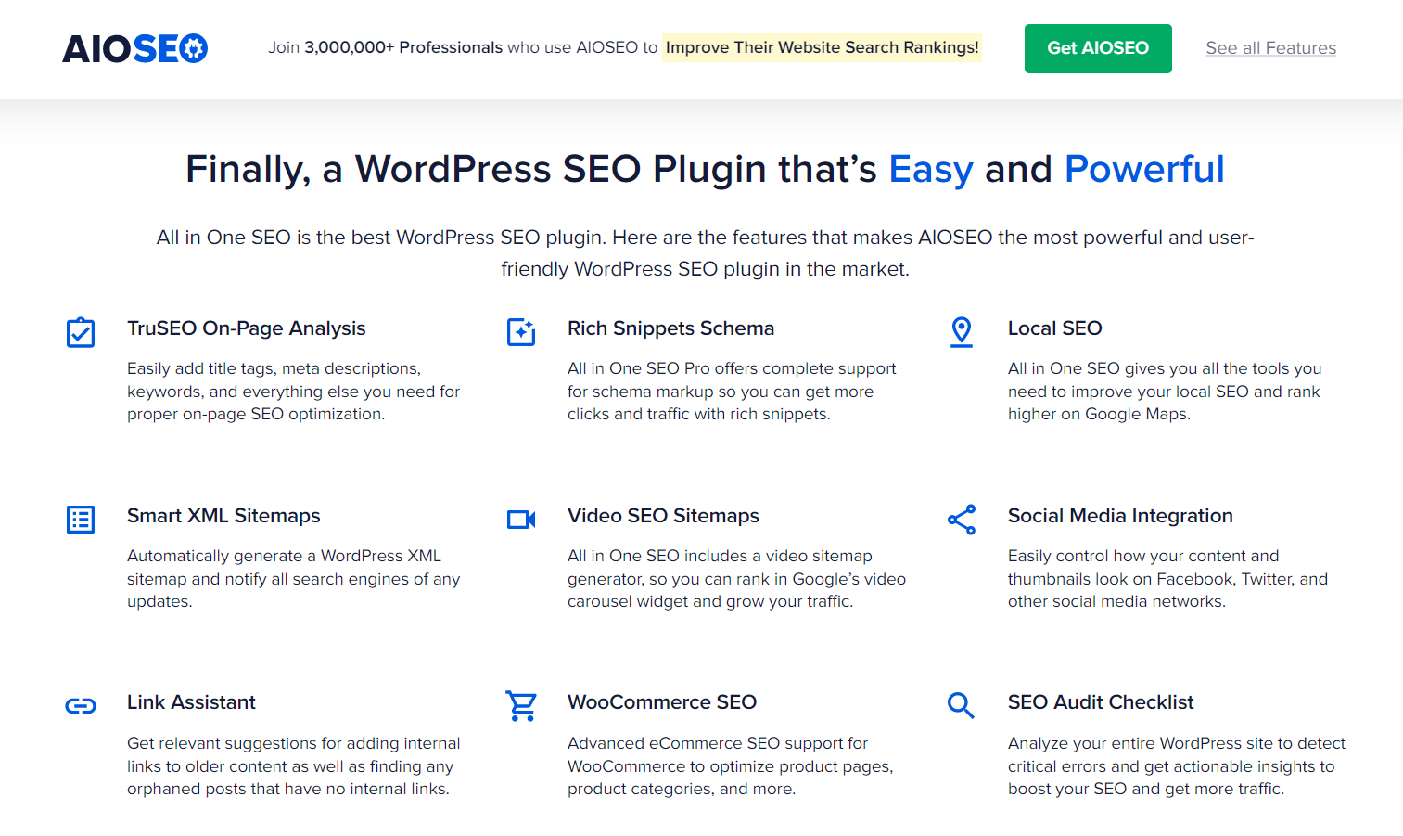

Both All in One SEO Pack (AIOSEO) and Yoast SEO have pros and cons, making comparing them a bit tricky. Both are great plugins that can help you make your site more search engine-friendly with minimal effort.

Both plugins have free versions and are easy to set up on your WordPress website. They’re regularly updated to ensure compatibility with all types of WordPress websites, including popular themes such as Avada or Divi. According to the official sites, both also boast large user bases –over 10 million users.
The most crucial difference between All in One SEO Pack (AIOSEO) vs. Y.oast SEO is their features list: All in One SEO Pack has a lot more tools than its competitor does but doesn't offer any extra functionality beyond what's available with its free version (other than an option for some advanced features if you upgrade). This can be seen as a good thing – all those extra features may not be necessary for most users!

How Does the All in One SEO Plugin Work?

The All in One SEO plugin is a well-known tool that helps you optimize your website for search engines. It’s compatible with all the major WordPress themes and lets you add meta descriptions and keywords to all your pages and posts.
AIOSEO also lets you analyze the performance of each page on your site individually so that you can see which elements are working well, which ones need tweaking, and what needs to be changed completely.

Robots.txt File creation using All in One SEO Pack

AIOSEO lets you create a Robust.txt file of your own. In addition to creating a robots.txt file for your site, you can use the All In One SEO Pack plugin’s Search Engine Optimization (SEO) options to block search engines from crawling your site or specific pages on your site. This is an effective way of preventing unwanted robots from scraping and indexing key content on your website. Still, it is not recommended to use this method unless there are valid reasons for doing so.

WooCommerce SEO with AIOSEO

With AIOSEO, you can add all of your store’s products to an XML sitemap and submit it to Google Webmaster Tools. This will help with your product indexing, which can ultimately lead to a higher search result ranking for those important keywords that are driving people to your site.
AIOSEO also includes the ability to add custom meta information such as price, size, and color for each product. This extension is excellent for optimizing product pages to rank well in search results!

Social Media Integration feature
AIOSEO also provides social media integration features. It supports all major social media platforms, including Facebook, Twitter, Pinterest, LinkedIn, and Google+.
AIOSEO automatically creates social media profiles for your website and can add share buttons to make it easier for visitors to share content via their favorite social networks. It also adds they follow buttons so readers can follow you on various platforms.

Rich Snippet Schema

Rich Snippet Schema is a way to add structured data to your website. It helps Google display more information about your website in search results and a rich format.
Rich Snippet Schema is an integral part of Search Engine Optimization (SEO) as it helps us improve our ranking on search engines by increasing the click-through rate (CTR).
You can enable Rich Snippet Schema for your WordPress blogs using the All In One SEO Plugin (AIOSEO).

Local and On page SEO features in AIOSEO

Local SEO ranks your business on the first page of Google search results for a particular location. This is important because people who are looking local company or service will most likely use Google to search for it.
On-Page SEO is all about optimizing your website content to rank higher in Google search results. A good On-Page SEO plugin like AIOSEO can help you optimize your site and get better rankings on Google, which means more traffic and sales!

AIOSEO Vs. Yoast – Which is The Best WordPress SEO Plugin?

When it comes to SEO, you want nothing but the best. This is why we’ve chosen AIOSEO as your blog's ultimate WordPress SEO plugin. The AIOSEO plugin is more straightforward than Yoast and so many other competitors in usability and functionality – not to mention speed!
AIOSEO has more features than Yoast SEO:
- AIOSEO has advanced search engine optimization features such as automatic breadcrumbs (which helps people find their way around your site via search), image alt tags, meta keywords, meta descriptions, and titles (for both posts and pages,) among others. It also allows you to add schema markup on individual pages or posts, which means that if you have an e-commerce store or offer lead generation services/products on your website, then you can take advantage of this feature by creating rich snippets that will increase visibility in Google SERPs (Search Engine Result Pages).
- AIOSEO's interface is easy-to-use, while Yoast's can be cumbersome, especially for beginners who want some guidance regarding optimizing their websites.

All In One SEO can help you rank your website on the first page of Google search results.3 million users have tried; grab your chance today

Pricing of AIOSEO

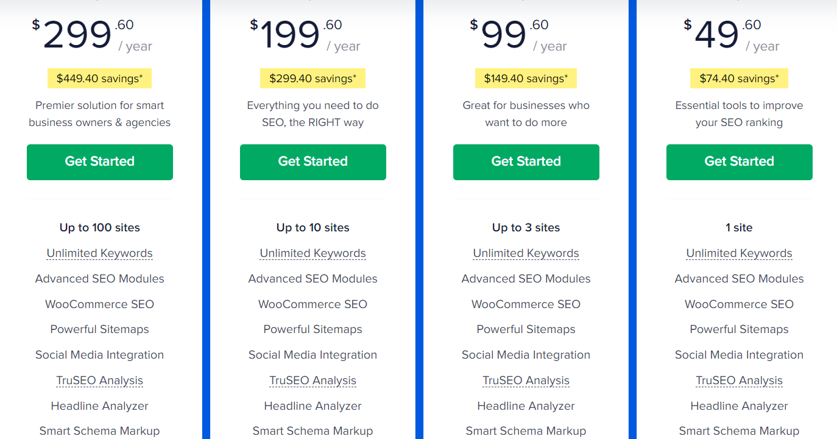

All In One SEO Plugin (AIOSEO) is a premium WordPress plugin that offers everything you need to optimize your site for search engines. The plugin comes in three plans: Basic, Plus, and Pro.

The Basic plan is $49.50/year, the Plus plan is $99.50/year, and the Pro plan is $199.50/year.

With this plugin, you get unlimited keywords and advanced SEO modules that allow you to make sure your site is ranking well in all of the major search engines. You'll also have access to a powerful sitemap generator and social media integration with Facebook Open Graph tags, Twitter Cards, and Google+ meta tags.

There are also other features like TruSEO Analysis, which helps you analyze your content by looking at over 200 on-page factors; Headline Analyzer, which allows you to write better headlines; Smart Schema Markup, which helps your website's information to be displayed correctly in search results and Custom Breadcrumbs that can be used on any page in your site.

Conclusion

In this article, we’ve covered some of the best features of the AIOSEO plugin. We know that if you want to rank your website on the first page of Google search results, you must use a good SEO plugin. With the All in One SEO Pack WordPress plugin, we hope you can get started with one of the most powerful SEO plugins available today!
Follow Andlang for more blogs like these in the future, and keep yourself updated with everything on the web.

